Questions for the course CEG4136
This list of questions and problems is based on questions that I developed or used for assignments, quizzes and exams during the period of 2004-2013. Please note that this document is a work in progress and is intended for the sole use of the CEG4136 students. I apologize if some questions are repeated. I also acknowledge that I have not included references for questions that are taken from other resources and that I plan to do that in near future.

I would like to thank Iype Joseph for compiling this material.

Miodrag Bolic
December 1, 2013

Table of Contents
1 Models and Performance metrics 3
1.1 Questions related to the lecture 3
1.2 Short questions 3
1.3 Problems 5
2 Programming 6
2.1 Questions related to the lecture 6
2.2 Short questions 6
2.3 Problems 10
3 Caches 25
3.1 Questions related to the lecture 25
3.2 Short questions 25
3.3 Problems 29
4 Snooping caches - implementation 33
4.1 Questions related to the lecture 33
4.2 Short questions 34
4.3 Problems 35
5 Directory based protocols 51
5.1 Questions related to the lecture 51
5.2 Short questions 52
5.3 Problems 53
6 Interconnection networks 55
6.1 Questions related to the lecture 55
6.2 Short questions 56
6.3 Problems 65
7 Multithreading 77
7.1 Questions related to the lecture 77
7.2 Short questions 77
7.3 Problems 78
8 Hypervisors 78
8.1 Questions related to the lecture 78
8.2 Short questions 79
8.3 Problems 79
9 Processor architectures, accelerators and scheduling 79
9.1 Short questions 79
9.2 Problems 83

Models and Performance metrics

Questions related to the lecture

Short questions
From: http://www.crazyengineers.com/forum/computer-science-engineering/38059-computer-architecture-question-bank.html
Q. Discuss various models for multiprocessors.
Q. Differentiate between Multiprocessors and Multicomputers.
Q. Give Taxonomy of MIMD Computers.
Q. Give architectural details of SIMD Computers.

Q. What is the degree of parallelism? What degree of parallelism is assumed in the derivation of Amhdal’s law?

Q. What criterion is used for Flynn’s classification on parallel systems?

Q. Scalability means that the speedup increases linearly when the number of processors increases and the problem size increases as well.
a. yes
b. no

Q. What is the maximum efficiency of a parallel processing system?
a. 1
b. >1
c. 0
d. n

Q. Are the assumption that there is no overhead in communication and synchronization the only assumptions made for derivation of Amhdals law?

Q. Why is it difficult to further increase the number of pipelining stages in the processors?

Q. It is possible to have speedup better than P where P is the number of available processors.
- True
- False

Q. Shared-variable communication
a) Is based on the use of shared variables in local cache memories for inter-process communication.
b) Uses a critical section that must be executed by only one processor at a time.
c) Is used for multi-computer communication.

Q. Multi-computers
a) Each processor executes the same program at the exactly same time as the others.
b) Communication between processors is done only with shared memory.
c) Are built with heterogeneous computers and even can run different OS across different processors.

Q. Someone said that system X is faster than system Y because a 1.4GHz clock is attached to X, while a 700MHz.clock is attached to Y. How should you react?
a) This is great! I want system X, if it does not heat up too much.
b) He is nuts! System X is a RISC processor and system Y is a CISC processor, which means X is probably slower.
c) Let me run a few benchmarks that will take into account the compiler, the RAM, the cache and the whole system
Q. Does efficiency of a program running on a parallel machine depend on the problem size (in the parallel addition problem, the problem size is the number of elements to add in parallel)? Why?

Q. Maximum efficiency for n-processor system is n.

- True
- False

Q. What is SPMD?
Q. Compute average parallelism if the following parallelism profile is given:
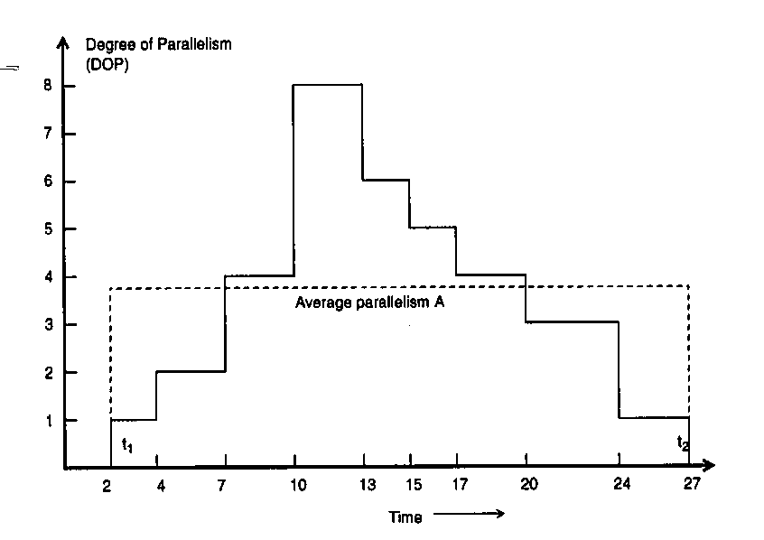

Q. What are advantages and disdvantages of Drystone benchmark?

Q. Write an expression for Amhdal’s law that includes communication delay.

Q. What is the difference between SIMD and SPMD?

Q. What is super linear speedup? Describe situations where super linear speedup can occur?

Q. What are synthetic benchmarks?

Q. List several features that good benchmark programs need to have.

Problems
Q.
- Consider an algorithm in which 1/a of the time is spent executing computations that must be done in sequential fashion. What is the maximum speedup achievable by the parallel form of the algorithm?

- Total time for implementation of the program on sequential processor is T(1)=1ms. The program is modified so that it can be executed on multiprocessing system with n=10 processors. Parallelism profile is shown in the figure bellow. Assume that there is no overhead due to communication and synchronization. Find the speedup and efficiency of this parallel system in comparison with the sequential one.

Q. Consider a program that performs multiplication of m numbers. Assume that multiplication operation takes 3 time units and that the loop overhead is negligible. Consider the execution of the program on 1 and on n processors implemented using a single shared bus. Assume that at the beginning, m/n input numbers were stored in local memories of the processors. Assume that the total time needed to transmit one message through the bus is 10 time units?
- What would be the speedup in case the program is implemented n processors?
- What is the efficiency?

Programming

Questions related to the lecture

Short questions
Q. Is it possible to implement message passing method on a system with shared memories such as COMA?
a. yes
b. no

Q. Consider a multiprocessor system with 2 processors (A and B) with their individual caches that are connected via a bus with a shared memory. Variable x is originally x=3. Given is the following sequence of operations: 1. A reads variable x 2. B reads variable x 3. B updates x so that x=x+2 4. A updates x so that x=x*2 5. B reads variable x. What will processor B read in step 5 if no cache coherence mechanism is implemented.
- 3
- 5
- 10

Q. What are the size of the task and the frequency of communication in the system with fine-grained parallelism?

Q. How long does it take to add 64 numbers using 4 processors. Communication and computation take one unit time. Assume that processors are connected using a single bus.
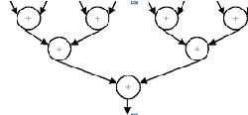
- 18
- 20
- 22
- 24

Q. Where is the mutex stored in general purpose processing systems:
a. In memory
b. In special hardware module next to each processor
Q. What is the reason for using Barrier in parallel programming?
- To provide mutual exclusion mechanism
- To provide a point for synchronization for multiple threads
- To lock the shared variable

Q. Barrier is used to provide
- Mutual exclusion
- global synchronization among all threads
- point-to-point synchronization

Q. Is OpenMP language or Application Programming Interface (API)? If it is API, what languages is it specified for? Is it for shared memory or for message passing systems?
- Programming Language for shared memory systems
- API for C and C++ for message passing systems
- API for C, C++ and Fortran for shared memory systems

Q. We need to apply mutual exclusion when:
- Two processes read from the same memory location
- Two processes write to the same memory location
- In both 1. and 2.

Q. For programs with each of the following sets of characteristics, would a shared-memory multiprocessor or a message-passing multiprocessor be a better choice, all other factors being the same?
a) Values tend to be computed well before they are used.
b) The control structure is very complicated, making it difficult to predict which data will be needed by each processor.

Q. Parallel virtual machine (PVM) and Message passing interface (MPI)
a) Provide complex parallel environment permits only homogeneous collection of machines to be used as a single large parallel computer
b) Provide a point-to-point message passing library.
c) For homogeneous communication, information is sent in machine independent format.
Q.
- Does MPI support non-blocking receive and send?
- Can we use non-blocking receive if the received value has to be used immediately in the next instruction?
- Is additional synchronization needed if we use non-blocking receive? Why?

Q. Why does deadlock occur? How can it be avoided?

Q. What are the three mechanisms used to create new communicators in MPI

Q. What does the concept of incremental parallelism in OpenMP mean?
Q. What is “incremental parallelism” in shared memory systems?
Q. Does MPI support MPMD programming? How?
Q. What is SPMD?

Q. Why is the following code for implementing software lock non-atomic?
lock: ld register, location /* copy location to register*/
cmp register, #0 /* compare with 0 */
bnz lock /* if not 0, try again */
st location, #1 / * store 1 to mark it locked */
ret /* return control to caller */
and
unlock: st location, #0 /* write 0 to location */
ret /* return control to caller*/

Q. Is OpenMP language or Application Programming Interface (API)? If it is API, what languages is it specified for?
Q. What is MPI? What is the difference between blocking and non-blocking receive commands of MPI?

Q. We would like to perform mathematical operations on matrices using a single processing system with a cache. The cache line is 16 bytes (4 words). The matrix is stored in the memory row by row (eg. A₁₁, A₁₂, ..., A_{1N}, A₂₁, A₂₂, ..., A_{2N}, ... A_{N1}, A_{N2}, ...,A_{NN}) . Each element of the matrix is an integer (4 bytes=1 word). Which of the two programs below would run faster and why? Estimate the total number of cache misses if N is larger than the size of the cache.

S=0;  For (i=1:N)  For (j=1:N)  S=S+Aij  End  End | S=0;  For (j=1:N)  For (i=1:N)  S=S+Aij  End  End

Q. Write an expression for Amhdal’s law that includes communication delay. What are the major assumption in deriving the Amhdal’s law (list at least two)?
Q. What is the reason for using LL (load linked) and SC(store conditional)? How do these instructions work?

Q. What is the reason for using Barrier in parallel programming? Please elaborate in at least two sentences.

Q. What is the purpose of mutex? How is implemented in Altera FPGA?

Q. How does test&set resolve problem of implementing the Lock? What is the disadvantage of test&set?

Q. Assume all 16 processors in a bus-based machine try to acquire test&set lock simultaneously (and only once each). How many bus transactions will it take until all processors have acquired the lock if all critical sections are empty (each processor simply does LOCK and UNLOCK with nothing in between).

Problems
Q.
- How can bus-based multiprocessor system with snooping cache coherence be used to facilitate implementation of LL and SC commands. Draw a block diagram.
- Show implementation of a lock (in assembly language) using LL and SC.
- When the lock is implemented using LL-SC pair, the number of bus transactions is reduced in comparison with the implementation that relies on Test&Set command. Why? In your explanation, refer to the block diagram from part a).

Q. In case the Store Conditional (SC) instruction fails, bus will not be accessed. How is that achieved? Describe what component needs to be added and what actions need to be performed in order for LL-SC to work.
Q. In the following program assume that SEND takes 500 cycles to finish and unrelated computation takes 600 cycles. How long does it take to execute this program? Assume that both threads can send their messages at the same time?
CODE FOR THREAD T1: CODE FOR THREAD T2:
A = 10; B = 5;
ASEND(&A,sizeof(A),T2,SEND_A); ASEND(&B,sizeof(B),T1,SEND_B);
<Unrelated computation;> <Unrelated computation;>
SRECV(&B,sizeof(B),T2,SEND_B); SRECV(&A,sizeof(B),T1,SEND_A);

- 500
- 600
- 1100

Q. Consider a machine with 2 processors that share the same memory. Multiply and Accumulate operation is performed:
global_MAC = X[0]*Y[0]+ X[1]*Y[1]+… X[N-1]*Y[N-1]
The MAC subroutine is implemented on both processors and it is shown below. Modify the program to make it suitable for execution in a four-processor machine.
If processor P1 starts executing MAC subroutine before the processor P0, will the final result be different. Why?

id = mypid (); // Assign identification number: id=0 for processor 0, and id=1 for processor 1
read_array(X, Y, N); //read arrays X and Y that have size N
if (id == 0) //initialize the MAC
{
LOCK(global_MAC);
global_MAC = 0;
UNLOCK(global_MAC);
}
BARRIER(2); //waits for all processors to get to this point in the program
local_MAC = 0;
for (i =id*N/2; i < (id+1)*N/2; i++)
local_MAC += X[i]*Y[i];
LOCK(global_MAC);
global_MAC += local_MAC;
UNLOCK(global_MAC);
BARRIER(2); //waits for all processors to get to this point in the program
END;

Q. The following MPI program is given. What is the order of printing? Why?

#include <stdio.h>
#include "mpi.h"
main(int argc, char** argv)
{
int my_PE_num;
MPI_Init(&argc, &argv);
MPI_Comm_rank(MPI_COMM_WORLD, &my_PE_num);
printf("Hello from %d.\n", my_PE_num);
MPI_Finalize();
}

MPI_Init : initiate computation
MPI_Comm_rank : determine the integer identifier assigned to the current process (processes in a process group are identified with unique, contiguous integers numbered from 0)
MPI_COMM_WORLD : default value which identifies all processes involved in a computation
MPI_Finalize : terminate computation

Q. The fetch-and-add atomic operation can be used to implement barriers, semaphores and other synchronization mechanisms. The semantics of fetch-and-add is such that it returns the value before the addition. Use the fetch-and-add primitive to implement a barrier operation suitable for a shared memory multiprocessor. To use the barrier, a processor must execute: BARRIER(BAR, N), where N is the number of processes that need to arrive at the barrier before any of them can proceed. Assume that N has the same value in each use of barrier BAR. The barrier should be capable of supporting the following code:
while (condition) {
Compute stuff
BARRIER(BAR, N);
}
A proposed solution for implementing the barrier is the following:
BARRIER(Var B: BarVariable, N: integer)
{
if (fetch-and-add(B, 1) = N-1) then
B := 0;
else
while (B <> 0) do {};
}
What is the problem with the above code? b) Write the code for BARRIER in a way that avoids the problem.

Q. Message passing systems
a) A message passing program running on two processors executes the following sequence of tasks:
Processor 1 | Processor 2
Compute for 1000 cycles  Receive message 1  Compute for 2000 cycles  Send message 2 to processor 2  Compute for 5000 cycles | Compute for 500 cycles  Send message 2 to processor 2  Compute for 500 cycles  Receive message 2  Compute for 5000 cycles
Assume that a processor that sends a message is busy for entire 1000 cycles time that it takes for the message to reach the destination processor. The delay from when a message is sent until when it is received on the destination processor is 1000 cycles, and it takes 500 cycles to complete RECEIVE operation if the message being received is available.
Show the execution and communication times using a Gantt chart. What is the total execution time?

Q. Message passing systems
a) A message passing program running on two processors executes the following sequence of tasks:
Processor 1 | Processor 2
Compute for 1000 cycles  Receive message 1  Compute for 2000 cycles  Send message 2 to processor 2  Compute for 5000 cycles | Compute for 500 cycles  Send message 1 to processor 1  Compute for 500 cycles  Receive message 2  Compute for 5000 cycles
Assume that a processor that sends a message is busy for entire 1000 cycle’s time that it takes for the message to reach the destination processor. The delay from when a message is sent until when it is received on the destination processor is 1000 cycles, and it takes 500 cycles to complete RECEIVE operation if the message being received is available. What is the total execution time?
b) Consider a 64-processor system and assume a 64-node hypercube network architecture is used to connect all different nodes. Based on the E-cube routing algorithm show how to route a message from node A (101101) to node B (011010).

Q. Parallel programming
1a) Consider a shared memory system with two processors. What value will processor P1 print? If variable flag is used only in this portion of the code of processors P1 and P2, do we need to use lock (mutex)? Why?

P1 | P2
….  A=0;  while (flag==0) do nothing;  print A;  … | …  A=1;  flag=1;  …

1b) System deadlock refers to a situation in a multiprocessor when concurrent processes are holding resources and preventing each other from completing their execution. Is it possible that this software causes dead lock situation?
Q.
a. Consider a following program for parallel matrix addition using a message passing parallel system. Assume that the array_to_sum is stored initially in the local memory of processor 0. Using the same logic as in the code for parallel addition, write a program for parallel matrix multiplication on message passing processor C=AxB. Assume that matrices A and B are initially stored in processor 0 and that the result has to be printed by processor 0.
INITIALIZE; //assign proc_num and num_procs
if (proc_num == 0) //processor with a proc_num of 0 is the master,
//which sends out messages and sums the result
{
read_array(array_to_sum, size); //read the array and array size from file
size_to_sum = size/num_procs;
for (current_proc = 1; current_proc < num_procs; current_proc++)
{
lower_ind = size_to_sum * current_proc;
upper_ind = size_to_sum * (current_proc + 1);
SEND(current_proc, size_to_sum);
SEND(current_proc, array_to_sum[lower_ind:upper_ind]);
}
//master nodes sums its part of the array
sum = 0;
for (k = 0; k < size_to_sum; k++)
sum += array_to_sum[k];
global_sum = sum;
for (current_proc = 1; current_proc < num_procs; current_proc++)
{
RECEIVE(current_proc, local_sum);
global_sum += local_sum;
}
printf(“sum is %d”, global_sum);
}
else //any processor other than proc_num = 0 is a slave
{
sum = 0;
RECEIVE(0, size_to_sum);
RECEIVE(0, array_to_sum[0 : size_to_sum]);
for (k = 0; k < size_to_sum; k++)
sum += array_to_sum[k];
SEND(0, sum);
}
END;

Q. Message passing systems
a. Consider a following program for parallel multiplication using a message passing parallel system. Assume that the numbers to multiply are stored on an external device (such as hard drive).
size = 100000;
INITIALIZE; //assign proc_num and num_procs
if (proc_num == 0) //processor with a proc_num of 0 is the master,
//which sends out messages and multiplies the result
{
n= N/num_procs;
global_result = 1;
while (!eof()) // continue until the end of the file containing the numbers to multiply
{
lmult = 1;
read_array(array_to_multiply, size); //read the array and array size from file
size_to_multiply = size/num_procs;
for (current_proc = 1; current_proc < num_procs; current_proc++)
{
lower_ind = size_to_multiply * current_proc;
upper_ind = size_to_multiply * (current_proc + 1);
SEND(current_proc, size_to_multiply);
SEND(current_proc, array_to_multiply[lower_ind:upper_ind]);
}
//master nodes multiplies its part of the array
for (k = 0; k < size_to_multiply; k++)
lmult *= array_to_multiply[k];

global_mult *= lmult;
for (current_proc = 1; current_proc < num_procs; current_proc++)
{
RECEIVE(current_proc, local_mult);
global_result *= local_mult;
}
}
// terminate the slave processors
for (current_proc = 1; current_proc < num_procs; current_proc++)
{
SEND(current_proc, 0);
}
printf(“sum is %d”, global_mult);
}
else //any processor other than proc_num = 0 is a slave
{
RECEIVE(0, size_to_multiply);
while (size_to_multiply > 0)
{
mult = 1;
RECEIVE(0, array_to_multiply[0 : size_to_multiply]);
for (k = 0; k < size_to_multiply; k++)
mult *= array_to_multiply[k];
SEND(0, mult);
RECEIVE(0, size_to_multiply); // check if there are still number to add.
}
}
END;

Let’s assume that the execution time of the operations is:
- read_array():
- Device access delay: 10 μs
- Data transfer from the device to the memory of processor 0: 100 numbers / μs
- Data transfer between processors 1000 numbers / μs. Add an extra 1 μs for communication overhead. Assume that SEND (and RECIEVE) is blocking which means that next command can start only after the SEND transaction is over.
- Multiplication performance: 50 multiplications / μs
Let's assume that the execution time of all other operations is negligible.
i. Calculate the speedup factor of this program when the number of processors is 10. What is the speedup when the number of processors is 100 (8 points)?
ii. Explain how you could modify the algorithm to improve the speedup (2 points).
_________________________________________________________________________________________

Q. We have to perform parallel addition of M=128 integer numbers on N=4 processors. Assume that the interconnection network is built in a way that processors 1 and 2; 1 and 3; and 3 and 4 can communicate directly.
- Explain how the program for parallel addition would work.

b1) Assuming that addition takes 1 time unit and communication between processors 0 time units, draw the parallelism profile.
b2) What is the average parallelism? Will average parallelism increase if we increase the problem size M?

c1) Assume that addition takes 1 time unit and time to send and receive one integer number takes 2 time units. What is the speed-up and efficiency of this parallel system?
c2) Derive the expression for speedup when M numbers are added on N processors. Addition takes T1 time units and communication takes T2 time units.

Q. Consider a following program for parallel addition using a message passing parallel system. Assume that the array_to_sum is stored initially in the local memory of processor 0. Using the same logic as in the code for parallel addition, write a program for parallel multiplication Y = a × X on the message passing system. Assume that array X and scalar a are initially stored in the local memory of the processor 0 and all the elements of the array Y have to be printed by processor 0 after they are computed.

INITIALIZE; //assign proc_num and num_procs
if (proc_num == 0) //processor with a proc_num of 0 is the master,
//which sends out messages and sums the result
{
read_array(array_to_sum, size); //read the array and array size from file
size_to_sum = size/num_procs;
for (current_proc = 1; current_proc < num_procs; current_proc++)
{
lower_ind = size_to_sum * current_proc;
upper_ind = size_to_sum * (current_proc + 1);
SEND(current_proc, size_to_sum);
SEND(current_proc, array_to_sum[lower_ind:upper_ind]);
}
//master nodes sums its part of the array
sum = 0;
for (k = 0; k < size_to_sum; k++)
sum += array_to_sum[k];
global_sum = sum;
for (current_proc = 1; current_proc < num_procs; current_proc++)
{
RECEIVE(current_proc, local_sum);
global_sum += local_sum;
}
printf(“sum is %d”, global_sum);
}
else //any processor other than proc_num = 0 is a slave
{
sum = 0;
RECEIVE(0, size_to_sum);
RECEIVE(0, array_to_sum[0 : size_to_sum]);
for (k = 0; k < size_to_sum; k++)
sum += array_to_sum[k];
SEND(0, sum);
}
END;

Q.
Consider a following program for parallel addition of n elements of the array Z using a shared memory parallel system.
a) Do we need to place the additional BARRIER in this program in order to work correctly? Where? Why?
b) Your task is to modify this program in order to compute cumulative sums C. Cumulative sum C is an array of n elements which are computed as C(i)=Z(1)+Z(2)+…Z(i).

An example for parallel computation of cumulative sum for 12 elements and for M=3 processors is:
Processor 0 | Processor 1 | Processor 2
C(0)=Z(0) | C(4)=Z(4) | C(8)=Z(8)
C(1)=Z(0)+Z(1) | C(5)=Z(4)+Z(5) | C(9)=Z(8)+Z(9)
C(2)=Z(0)+Z(1)+Z(2) | C(6)=Z(4)+Z(5)+Z(6) | C(10)=Z(8)+Z(9)+Z(10)
C(3)=Z(0)+Z(1)+Z(2)+Z(3) | C(7)=Z(4)+Z(5)+Z(6)+Z(7) | C(11)=Z(8)+Z(9)+Z(10)+Z(11)
Computations of C(0) to C(3) on processor 0, C(4) to C(7) on processor 1, and C(8) to C(11) on processor 2 are done in parallel. After that, processors 1 and 2 have to update its cumulative sums:
Processor 0 | Processor 1 | Processor 2
 | C(4)=C(4)+C(3) | C(8)=C(8)+C(3)
 | C(5)=C(5)+C(3) | C(9)=C(9)+C(3)
 | C(6)=C(6)+C(3) | C(10)=C(10)+C(3)
 | C(7)=C(7)+C(3) | C(11)=C(11)+C(3)

In the end only processor 2 has to update the cumulative sums:
Processor 0 | Processor 1 | Processor 2
 |  | C(8)=C(8)+C(7)
 |  | C(9)=C(9)+C(7)
 |  | C(10)=C(10)+C(7)
 |  | C(11)=C(11)+C(7)

Modify given program for parallel addition to support parallel computation of cumulative sums on M processors. Input array is Z and it has n elements. Cumulative sums C(1), …., C(n) are printed by a processor 0. Please explain and comment your program in order to get full credit.

Sum all the elements of an array Z of size n.
INITIALIZE; //assign proc_nums and M, where M is the number of processors
read_array(Z, n); //read the array and array size n from file
if (proc_num == 0) { //initialize the sum
LOCK(global_sum);
global_sum = 0;
UNLOCK(global_sum);
}
local_sum = 0; size_to_sum = n/M;
lower_ind = size_to_sum * proc_num;
upper_ind = size_to_sum * (proc_num + 1);

for (i = lower_ind; i < upper_ind; i++)
local_sum += Z[i];
//if n =100, M=4, processor 0 sums 0 to 24, proc 1 sums 25 to 49, etc

LOCK(global_sum); //locks the sum variable so only this process can change it
global_sum += local_sum;
UNLOCK(global_sum); //gives the sum back so other procs can add to it

BARRIER(M); //waits for M processors to get to this point in the program
if (proc_num == 0)
printf("sum is %d", global_sum);
END;

Q. The following MPI program is given. What is the order of printing? Why?

#include <stdio.h>
#include "mpi.h"
main(int argc, char** argv)
{
int my_PE_num;
MPI_Init(&argc, &argv);
MPI_Comm_rank(MPI_COMM_WORLD, &my_PE_num);
printf("Hello from %d.\n", my_PE_num);
MPI_Finalize();
}

Q. Shared memory systems

- Please find bellow implementation of software LOCK. Explain why this lock is not atomic. What would you change (propose) to make it atomic?
lock: ld register, location /* copy location to register*/
cmp register, #0 /* compare with 0 */
bnz lock /* if not 0, try again */
st location, #1 / * store 1 to mark it locked */
ret /* return control to caller */
and
unlock: st location, #0 /* write 0 to location */
ret /* return control to caller*/

b)
The following code is executed on num_procs =3 processors. The number of elements to add is size=90 and all the elements of the array have value 1. Variable global_sum is shared. Two cache coherence protocols are used: write through write invalidate and write-back write invalidate cache. Present the content of local caches as well as global memory related to the variable global_sum as well as the state of the cache for:
- write through write invalidate cache
- write-back write invalidate

INITIALIZE; //assign proc_nums and num_procs
read_array(array_to_sum, size); //read the array and array size from file
if (proc_num == 0) //initialize the sum
{
LOCK(global_sum);
global_sum = 0;
UNLOCK(global_sum);
}
local_sum = 0; size_to_sum = size/num_procs;
lower_ind = size_to_sum * proc_num;
upper_ind = size_to_sum * (proc_num + 1);
for (i = lower_ind; i < upper_ind; i++)
local_sum += array_to_sum[i];
//if size =100, num_proc=4, processor 0 sums 0 to 24, proc 1 sums 25 to 49, etc
LOCK(global_sum); //locks the sum variable so only this process can change it
global_sum += local_sum;
UNLOCK(global_sum); //gives the sum back so other procs can add to it
BARRIER(num_procs); //waits for num_procs to get to this point in the program
if (proc_num == 0)
printf("sum is %d", global_sum);
END;
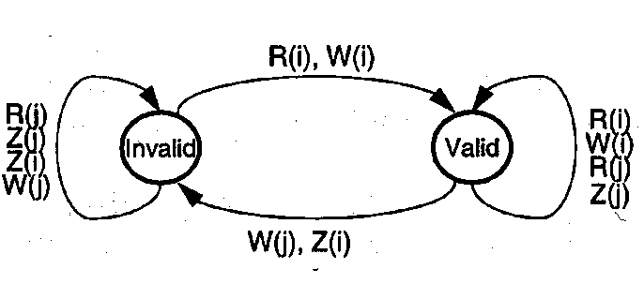
R = Read, W = Write, Z = Replace
i = local processor, j = other processor
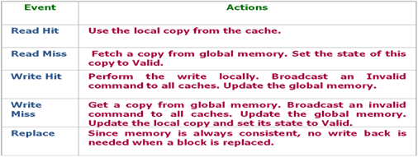
Figure 1 State machine and the table for write through write invalidate cache coherence protocol

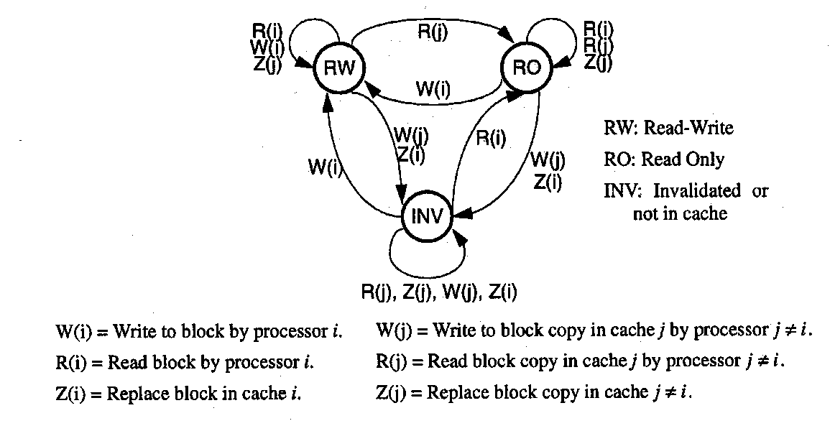
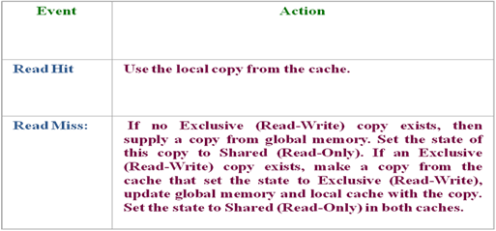
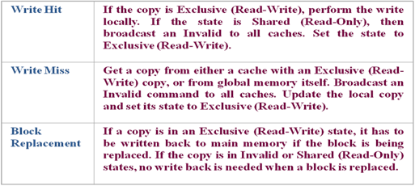
Figure 2 State machine and the table for write-back write invalidate cache coherence protocol

Q. The following program is to be executed on a uniprocessor, and a parallel version of it on the shared memory multiprocessor.

For i=1:1024
Sum(i)=0
For j=1:i
Sum(i)=sum(i)+j
End
End

Suppose statements 2 and 4 each take 2 machine cycles including all CPU and memory activities. Ignore the overhead caused by the software loop and all other system overheads.
- What is the total execution time of the program on a single processor?
- Devide i-loop iterations among 32 processors with preschedule as follows: Processor 1 executes the first 32 iterations (i=1:32), processor 2executes next 32 iterations (i=33:64) and so on. What are the execution time and speedup factor compared with part a?
- Propose modification of the program from b) to facilitate balanced execution of all the computational work load over 32 processors? By balanced execution, we mean an equal number of additions assigned to each processor with respect to both loops. What is the speedup over the single processor execution?

You might find this formula useful:

$$S=\sum_{m=N1}^{N2}{m=\frac{N1+N2}{2}}(N2-N1+1)$$

Q.
Consider a program below written for a shared memory system that is used to add 4 elements of array A in parallel using 4 processors. What are the problems with this program (there are at least two)? Show by using an example how and why this program crashes. What do you need to modify to make this program work?

INITIALIZE; //assign proc_num and num_procs to each processor. Proc_num is number from 0 to 3
//assigned to processors
if (proc_num == 0) //initialize the sum
{
global_sum = 0;
}
global_sum += A[proc_num];
BARRIER(num_procs); //waits for num_procs to get to this point in the program
if (proc_num == 0)
printf("sum is %d", global_sum);
END;

Q.
You are writing an image processing code snippet, where the image is represented as a 2-d array of pixels. The basic iteration in this computation looks like:

for i = 1 to 1024
for j = 1 to 1024
newA[i,j] = (A[i,j-1]+A[i-1,j]+A[i,j+1]+A[i+1,j])/4;
Assume A is a matrix of 4-byte single precision floats stored in row-major order (i.e A[i,j] and A[i,j+1] are at consecutive addresses in memory). Assume that there are no array index out of bound errors. A starts at memory location 0. You are writing this code for a 32 processor machine. Each processing element has a 32 Kbyte direct-mapped cache and the cache blocks are 64 bytes. Assume that write through protocol is used and that no cache coherence mechanism is implemented.

- You try assigning 32 rows of the matrix assign 32 contiguous rows of the matrix to each processor. What is the actual ratio of computation to bus traffic that you expect? Please explain what you consider to be a bus transaction and how many bytes are involved in one transaction. State any other assumptions.
- Is there a need for adding synchronization primitives to this program? Why or why not?
- Find the number of bus transactions in case write-invalidation write back cache coherence protocol (for example MSI shown in Figure 1)?

Figure 1 State machine and the table for write-back write invalidate cache coherence protocol

Q.
The fetch-and-add atomic operation can be used to implement barriers, semaphores and other synchronization mechanisms. The semantics of fetch-and-add is such that it returns the value before the addition. Use the fetch-and-add primitive to implement a barrier operation suitable for a shared memory multiprocessor. To use the barrier, a processor must execute: BARRIER(BAR, N), where N is the number of processes that need to arrive at the barrier before any of them can proceed. Assume that N has the same value in each use of barrier BAR. The barrier should be capable of supporting the following code:
while (condition) {
Compute stuff
BARRIER(BAR, N);
}
1. A proposed solution for implementing the barrier is the following:
BARRIER(Var B: BarVariable, N: integer)
{
if (fetch-and-add(B, 1) = N-1) then
B := 0;
else
while (B <> 0) do {};
}

What is the problem with the above code? Write the code for BARRIER in a way that avoids the problem.

Caches

Questions related to the lecture

Short questions
Q. Consider a 32-bit microprocessor that has an on-chip 16Kbytes four-way set-associative cache. Assume that a cache line has a line size of four 32 bit words. Where in the cache is the word from memory location 0xABCDE8F8 mapped?
a. 15
b. 248
c.143
d.128
Q. A computer system contains a main memory of 32K bytes. It has also a 2-way set-associative cache. The size of the cache is 64Bytes and it has 4 words (16 bytes) per set. Assume LRU policy. The processor runs a program (that is a long sequence of load instructions) that fetches 18 words from locations 0, 4, 8,…, 68 in that order sequentially 10 times. Assume that the processor is a 5-stage pipelined and fully loaded with hazard detection unit, forwarding unit, stalling support, … Assume that the clock period of the processor is 10ns, that the access time for the cache is 10ns. Regarding memory timing, assume that it takes – 1 clock cycle to send the referenced address – 10 clock cycles for each DRAM access initiated – 1 clock cycle to send a word of data. How long will it take to execute this program if there is no cache and the processor is directly connected to the memory using 32-bit bus.
- 2164
- 2160
- 180
- 12
Q. Why does memory access time increases with the size of the memory for any type of the memory (cache, main memory, ...)?

Q. Why are cache controllers designed to support parallel tags in caches?

Q. How many bits per cache set are needed to support LRU replacement policy for 16-way set-associative caches? (here I mean the total number of bits needed for LRU for one set in all 16 lines)
- 4
- 16
- 64
- 256

Q. One of the architectures of bus-based shared memory systems relies on shared L2 caches. What is the reason for having shared L2 caches?

Q. List several advantages of a shared L2 cache among cores in multicore system compared to separate dedicated L2 cashes for each core?

Q. What is prefetch degree?
- The number of blocks that are prefetched
- The number of hardware units for prefetching
- The number of instruction caches

Q. Consider a machine with a byte addressable main memory of 2¹⁶ bytes and a block size of 8 bytes. Assume that a direct mapped cache consisting of 32 lines is used with this machine.
- How is a 16 bit memory address divided into tag, line number and byte number?

- Into what line would bytes with each of the following addresses be stored?
0001 0001 0001 1011
1100 0011 0011 0100
1101 0000 0001 1101
1010 1010 1010 1010

- Suppose the byte address 0001 1010 0001 1010 is stored in the cache. What are the addresses of the other bytes stored along with it?

- How many total bytes of memory can be stored in the cache?

- Why is the tag also stored in the cache?

Q. Why would we need a write-back buffer in case of block replacement? Does this cause a problem with sequential consistency? How is that problem addressed?
Q. Consider a parallel multiprocessing system on chip in which processors have 2 levels of caches (L1 and L2). Caches are inclusive. A snooping invalidate cache coherence protocol is used. Is L1 or L2 cache controller responsible for enforcing coherence within the chip. Why?
- Let’s assume now that cashes are non-inclusive i.e. the data might be read from the memory directly to L1 cache. How would cache coherence be maintained in this case?

Q. In a dynamic Non-Uniform Cache NUCA cache (multi/manycore with distributed L2 cache), a block can be placed in one of many different physical banks. Hence, finding the block is a non-trivial problem. Please suggest some efficient ways to find the block.

Q. Put in the right order the following memory hierarchy: 1 backup tape, 2 cache, 3 hard disk, 4 main memory, 5 CPU Registers.
a) 5-2-4-3-1
b) 5-4-2-3-1
- 5-1-3-4-2

Q. Registers can be considered as the part of memory hierarchy. We load variables to the registers, modify them and store them back to the memory. Why isn’t coherence a problem with registers as it is with the cache memory?

Q. Why does increasing the capacity of the cache tend to increase its hit rate?

Q. Why do we need dirty bit for write-back caches?

Q. Consider the system with a processor, primary, secondary cache and the memory. Assume that virtual memory system does not exist. Assume a situation in which the processor attempts to fetch an instruction and a cache miss occurs in both primary and secondary caches. Describe steps needed by the cache controllers to fetch the instruction from the main memory to the processor.

Q. What is the advantage of having the secondary cache?

Q. What does LRU strategy mean? For which cache organization is LRU used: direct-mapped, set-associative, or fully associative?

Q. Consider a processing system with a processor, TLB, 2 levels of caches and a memory. Next, consider a moment when the computer is just turned on and all the caches, TLB and memory are empty. Describe set of actions needed to fetch the first instruction to the processor.

Q. Draw a block diagram of a shared memory system that uses physically distributed memories. How is the data shared in this system? How is data written to or read from distributed memories?

Q. What communication networks are well suited for broadcasting? How is that used in resolving cache coherence issues?

Q. Describe the process of loading data a) from a local and b) from a remote memory in case of CC-NUMA architecture?

Q. Why would we need a writeback buffer in case of block replacement? Does this cause a problem with sequential consistency? How is that problem addressed?

Q. In a dynamic Non-Uniform Cache NUCA cache (multi/manycore with distributed L2 cache), a block can be placed in one of many different physical banks. Hence, finding the block is a non-trivial problem. Please suggest some efficient ways to find the block.

Q. Processors used in Freescale’s QorIQ chip have 256 KB L2 cache that can be configured also as SRAM and stashing memory. What would be the advantage of using that memory as a cache, regular memory or stashing memory. Give examples of applications that would benefit from each of these configurations.

Problems
Q. The sequence of 10 byte accesses for a direct-mapped cache with 4 blocks of 4 bytes is shown below. Accesses number 8, 9 and 10 will result in the following sequence of hits/misses:
 | Address (binary) | Hit/Miss
1. | 110001 | Miss
2. | 100111
3. | 001111
4. | 001100
5. | 010001
6. | 110010
7. | 100101
8. | 001110
9. | 100001
10. | 110101

- M, M, M
- M, H, M
- H, M, M
- H, M, H

Q. A direct mapped cache with WTWA (i.e. Write Through Write Allocate) is used to reduce the average memory access time on a computer. This cache holds 4K entries, 16-bit data, and ties into a 32-bit address bus with no byte or word select bits. Determine the contents of the cache and the memory below after the memory requests shown are sent to the cache. Immediately after powering up, the cache is initially empty and all valid bits are reset to indicate entries are invalid. Keep track of hits and misses so you can compute the cache miss rate when you are done. All values are in hex, “X” means undefined.
Cache Before Cache After
Block | Valid | Tag | Data |  | Block | Valid | Tag | Data
1 | 0 | X | X |  | 1
2 | 0 | X | X |  | 2
3 | 0 | X | X |  | 3
4 | 0 | X | X |  | 4
5 | 0 | X | X |  | 5

Memory Before Memory After
Address | Data |  | Address | Data
00100003 | 0ACE |  | 00100003
00040003 | 1234 |  | 00040003
00040005 | 789A |  | 00040005
00050004 | 0ABE |  | 00050004

Memory Requests
Address | Type | Data | Hit (y/n)
00040003 | Read
00050004 | Write | 0ECE
00040005 | Read
00100003 | Write | 00EE
00040005 | Read
00040005 | Read
00050004 | Read
00040003 | Read
00040005 | Read
00100003 | Read

Cache miss rate (include reads only) = ___________%

Q. A four-way set associative cache is given the memory operations shown below. It contains four lines and has one word per block A LRU (Lease Recently Used) replacement policy is used on this cache. The cache is initially empty except for the two entries shown. The first column of the cache gets the first entry after the valid bits have been reset and then it fills left to right. In the blanks provided in the cache below, list the original address values only (i.e. 12 in blank, means tag address and data for memory location 12 is in cache).
Block | Element 1 | Element2 | Element 3 | Element 4
0 | 4
1 | 1
2
3
Memory Read Operations Final Cache Contents
Address | Hit (y/n)
0
1
5
19
25
9
1
13
22
4
21
22
23
5
999
401

Hit rate for all memory operations is ____________%

Q. Consider a multiprocessor system with two processors (P1 and P2) and each processor has a cache. Initially, there is no copy of variable X in any of the caches and X=10. Draw the write through – write invalidate coherence protocol state diagram and show the state of variable X in caches and memory after each of the preceding statements is executed.
 | State of P1’s Cache | Content of X in P1’s Cache | State of P2’s Cache | Content of X in P2’s Cache | Content of memory location X
- Processor P1 reads Variable X
- P2 reads X
- P2 performs operation X=X+2
- P1 performs operation X=X*2
- P2 reads X

Q. Define, compare and comment on the following:

a) The three different shared memory system classification: UMA, NUMA, and COMA.

- Define the difference between write-back and write-through policies
Which policy should be used for the processor that run the applications with a large number of load and store operations and why?
Q. You are asked to perform capacity planning for a three-level memory system. The first level, M₁, is a cache with three capacity choices of 64 Kbytes, 128 Kbytes, and 256 Kbytes. The second level, M₂, is a main memory with a 4-Mbyte capacity, and the third level is a 400 Mbyte hard disk. Let c_{1,} c_{2,} and c₃ be the costs per byte and t₁, t₂, and t₃ the access times for M₁, M₂, and M₃, respectively. Assume c₁ = 20 c₂, c₂ = 2000 c₃, t₂ = 10 t₁, and t₃ = 1000 t₂. The cache hit ratios for the three capacities are assumed to be 0.7, 0.9, and 0.98, respectively.

- What is the average access time t_{a} in terms of t₁ = 20ns in the three cache designs? (Note that t₁ is the time from CPU to M₁, t₂ is that from CPU to M₂, and t₃ is that from CPU to M₃, not from M₁ to M₂.nor from M₂ to M₃).
- Express the average byte cost of the entire memory hierarchy if c₃ = $0.0001/Kbyte.
- Compare the three memory designs and indicate the order of merit in terms of average costs and average access times, respectively. Choose the optimal design based on the product of average cost and average access time.

Q.
a) Consider a 32-bit byte-addressable microprocessor that has an on-chip 4Kbytes direct-mapped cache. Assume that a cache line has a line size of two 32 bit words. Draw the block diagram of this cache and show its organization and how the different address fields are used to determine a cache hit/miss. How many bits are used for tags and how many for indexes?
b) Explain in details the sequence of operations in case of cache hit during the reading cycle. Assume that 4 way set-associative write-back cache with LRU replacement policy is used.
c) Explain in details the sequence of operations in case of cache miss during the reading cycle. Assume that 4 way set-associative write-back cache with LRU replacement policy is used and that the cache is full before the reading.

Q.
The Junkium processor has a 16KB, 4-way set-associative (i.e., each set consists of 4 blocks) data cache with 32-byte blocks. Here, a “KB” is 2¹⁰ bytes.
- How many total blocks are in the cache?
- Assuming that memory is byte addressable and addresses are 35-bits long, give the number of bits required for each of the following fields: Tag, Index, Offset
- What is the total size of the cache, including the valid, tag and data fields? Give an exact answer, in either bits or bytes.

Assume that the Junkium cache communicates with main memory via a 64-bit bus. The bus transaction consists of sending an address, waiting for the memory latency, and receiving the data. Suppose that each of these 3 operations (sending, waiting, receiving) takes 10ns, and that the operations may be overlapped in time.
- What is the miss penalty for the cache? In other words, how long does it take to send a request to main memory and to receive an entire cache block?
- If the cache has a 95% hit rate and a one-cycle hit time, and if we run a program of 1000 instructions which consists of 30% load/store instructions, what is the average number of memory stall cycles?

Snooping caches - implementation

Questions related to the lecture
???Questions about snooping protocol are missing

Why do we need dual directories in snooping caches?

Why do we need to store the data in a FIFO buffer for write-back caches?

Draw and explain the architecture of a cache controller with multiple caches?

What is the purpose of wired-NOR bus line for the MESI protocol?
Why is there a shared signal line between caches? How is this line implemented?

What are advantages and disadvantages of MESI in comparison with MSI?

What are the major features of MOESI protocols?

List cache protocol optimizations.
What is migratory sharing?
What is producer-consumer sharing? Give an example.

Where is the snooping cache controller places in multilevel caches?
What does cache0inclusivity have with placement of the controller?

What are the information that have to be exchanged between two caches (L1 and L2) for the snooping protocol with multilevel caches? Assume that the caches are inclusive. Describe information exchange both in L1->L2 and L2->L1 directions.

What are the transient states that need to be added to MSI protocol? What is the reason for adding transient states? Give an example.

Short questions
Q. Consider a shared memory system with two processors A and B. Each processor has a cache that is direct-mapped and has 64 blocks with block size of 16 bytes. The cache is initialized with all zeros. The following sequence is executed
1. Processor A writes a word 11 to the address 1200
2. Processor B reads a word from the address 1208
3. Processor A writes a word 33 to the address 1200
4. Processor B writes a word 44 to the address 1208
5. Processor A reads a word from the address 1208
Give the contents of the caches A after the last step step, if basic MSI write-back invalidation protocol is used. Show the whole cache line and use X for the words that you do not know.

Q. Consider a parallel multiprocessing system on chip in which processors have 2 levels of local caches (L1 and L2). Caches are inclusive. A snooping invalidate cache coherence protocol is used. Is L1 or L2 cache controller responsible for enforcing coherence within the chip.
a. L1
b. L2

Q. What is the purpose of wired-NOR bus line for the MESI protocol?

Q. Disadvantages of the MESI protocol in comparison with MSI protocol are (list all that apply):
- additional bus lines
- more complex state machine
- waiting for all processors to set the shared line before it is possible to change state after the read miss
- MESI works worse than MSI when the program runs only on one processor.

Q. Test_and_test&set causes larger number of invalidations in MSI invalidate protocol than test&set.
- True
- False

Q. Why are snoopy cache protocols difficult to implement when multiple processors are connected using static interconnection networks?

Q. Two processors require access to the same line of data from data memory. Processors have a cache and use the write-back write invalidated (MSI) protocol. Is it possible for two processors that share the same bus to repeatedly invalidate each other’s data even though they do not share any variable?

Q. What are disadvantages of snoopy protocols and why do people use centralized protocols for resolving cache coherence issues?

Q. We studied two main invalidation protocols - MSI and MESI protocols. The key difference between them is the existence of the valid-exclusive state in the latter. What do we gain by having this additional state?

Q. In a cache coherent system that uses the MESI protocol, when a program uses a load-lock instruction for acquiring a lock, is it better to load the lock into the cache in exclusive or shared state. Why?
Q. How does MESI protocol reduce the amount of bus transactions in comparison with MSI protocol?

Problems

Q. A two-processor shared memory system implements the basic MSI write-back invalidation protocol. For the following sequence of memory references, show the state of the cache line containing the variable ‘X = 10’ in each processors cache after each reference is resolved. Assume that the initial state of the line containing ‘X’ is invalid in both caches.

 | State of P1’s cache | Content of x in P1’s cache | State of P2’s cache | Content of x in P2’s cache | Content of memory location x
1. Processor P1 reads variable X |  |  |  |  | 10
2. P2 reads X
3. P2 performs operation X=X+2
4. P1 performs the operation X=X*2
5. P2 reads X

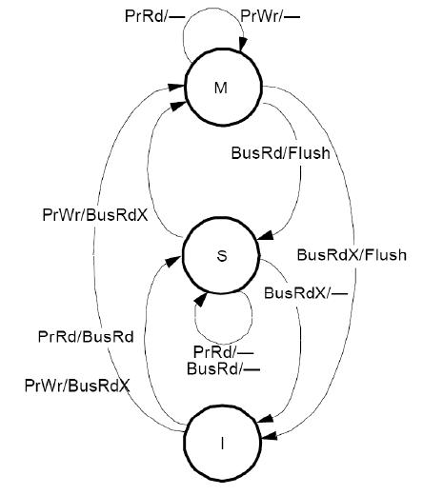

Q. A four-processor shared-memory system implements the MESI protocol for the cache coherence. For the following sequence of memory references, show the state of the line containing the variable a in each processor’s cache after each reference is resolved. Each processor starts out with the line containing a invalid in their cache.

 | P0’s cache | P1’s cache | P2’s cache | P3’s cache
P0 reads a
P1 reads a
P2 reads a
P3 writes a
P0 reads a

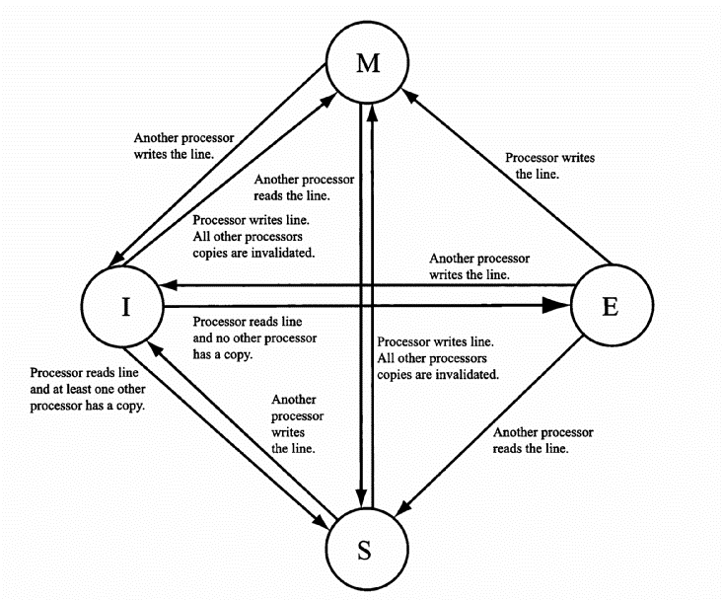

Q. The cache coherence mechanism for a multiprocessor system used a MESI protocol. Consider a system with two processors, P1 and P2, with the initial cache state shown in the following table. For this problem, assume each cache holds only 4 lines and uses direct-mapped organization.

Set | P1 Line | State | P2 Line | State
0 | L0 | M | L4 | I
1 | L1 | E | L5 | M
2 | L2 | S | L6 | S
3 | L3 | I | L7 | E

What is the state of each cache after the following sequence of memory references is completed?
Fill in the table below.
- P2 reads line L0
- P1 writes line L1
- P2 writes line L2
- P1 reads line L7

Set | P1 Line | State | P2 Line | State
0
1
2
3

Q. Three processors P1, P2, P3 with their individual caches are connected via a bus with a shared memory. In the initial state memory location x has the value 3 and the caches are empty. Given is the following sequence of operations:
- P1 reads location x.
- P2 writes 8 into location x.
- P3 reads location x.
- P1 reads location x.
- P2 writes 9 into location x.
Give the state of the cache controller (if a protocol is used) and the contents of the caches and the memory (x) after each step, if
(a) no snooping protocol is used. Caches are write-back caches.
(b) no snooping protocol is used. Caches are write-through caches.
(c) two-state write-through write invalidate protocol is used (Figure 1).
(d) basic MSI write-back invalidation protocol is used (Figure 2).

a) | State of P1’s cache | Content of x in P1’s cache | State of P2’s cache | Content of x in P2’s cache | State of P3’s cache | Content of x in P3’s cache | Content of memory location x
1. P1 reads location x.
2. P2 writes 8 into location x.
3. P3 reads location x.
4. P1 reads location x.
5. P2 writes 9 into location x.

b) | State of P1’s cache | Content of x in P1’s cache | State of P2’s cache | Content of x in P2’s cache | State of P3’s cache | Content of x in P3’s cache | Content of memory location x
1. P1 reads location x.
2. P2 writes 8 into location x.
3. P3 reads location x.
4. P1 reads location x.
5. P2 writes 9 into location x.

c) | State of P1’s cache | Content of x in P1’s cache | State of P2’s cache | Content of x in P2’s cache | State of P3’s cache | Content of x in P3’s cache | Content of memory location x
1. P1 reads location x.
2. P2 writes 8 into location x.
3. P3 reads location x.
4. P1 reads location x.
5. P2 writes 9 into location x.

d) | State of P1’s cache | Content of x in P1’s cache | State of P2’s cache | Content of x in P2’s cache | State of P3’s cache | Content of x in P3’s cache | Content of memory location x
1. P1 reads location x.
2. P2 writes 8 into location x.
3. P3 reads location x.
4. P1 reads location x.
5. P2 writes 9 into location x.

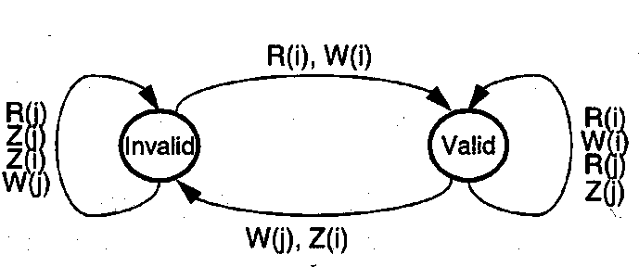
R = Read, W = Write, Z = Replace
i = local processor, j = other processor
Figure 1 State machine for write through write invalidate cache coherence protocol

Figure 2 State machine for write-back write invalidate (MSI) cache coherence protocol

Q. A four-processor shared-memory system implements the MESI protocol for the cache coherence. For the following sequence of memory references, show the state and the content of the line containing the variable a in each processor’s cache after each reference is resolved. Each processors start out with the line containing a invalid in their cache. Originally a=3.
 | State of P0’s cache | Content of a in P0’s cache | State of P1’s cache | Content of a in P1’s cache | State of P2’s cache | Content of a in P2’s cache | State of P3’s cache | Content of a in P3’s cache | Content of memory location a
P0 reads a |  |  |  |  |  |  |  |  | 3 | (4pt)
P1 reads a |  |  |  |  |  |  |  |  |  | (4pt)
P2 reads a |  |  |  |  |  |  |  |  |  | (4pt)
P3 performs a=a+1 |  |  |  |  |  |  |  |  |  | (4pt)
P0 reads a |  |  |  |  |  |  |  |  |  | (4pt)

MESI cache coherence protocol

Q. Consider a multiprocessor system with two processors (P1 and P2) and each processor has a cache. Also, consider the fo1lowing sequence of requests. Initially, there is no copy of variable X in any of the caches and X=10.
At time t1: processor P1 reads variable X.
At time t2: processor P2 reads variable X.
At time t3: processor P2 updates X; X = X + 2.
At time t4: processor P1 updates X; X = X*2.
At time t5: processor P2 reads variable X.
t5>t4>t3>t2>t1
Show the state and the content of variable X in caches and memory after each of the preceding statements is executed for the following protocols:
(a) Two-state write-through write invalidate protocol (Figure 1).
(b) Basic MSI write-back invalidation protocol (Figure 2).

a) | State of P1’s cache | Content of x in P1’s cache | State of P2’s cache | Content of x in P2’s cache | Content of memory location X
1. Processor P1 reads variable X
2. P2 reads X
3. P2 performs operation X=X+2
4. P1 performs the operation X=X*2
5. P2 reads X

R = Read, W = Write, Z = Replace
i = local processor, j = other processor
Figure 1 State machine for write through write invalidate cache coherence protocol

b) | State of P1’s cache | Content of x in P1’s cache | State of P2’s cache | Content of x in P2’s cache | Content of memory location X
1. Processor P1 reads variable X
2. P2 reads X
3. P2 performs operation X=X+2
4. P1 performs the operation X=X*2
5. P2 reads X

Figure 2 State machine for write-back write invalidate cache coherence protocol

Q. Consider a multiprocessor system with 2 processors (A and B) with their individual caches that are connected via a bus with a shared memory. Variable x is originally x=3. Given is the following sequence of operations:
- A reads variable x
- B reads variable x
- B updates x so that x=x+2
- A updates x so that x=x*2
- B reads variable x
Give the state of the cache controller and the contents of the caches and the memory (x) after each step, if
(a) two-state write-through write invalidate protocol is used (Figure 1).
(b) basic MSI write-back invalidation protocol is used (Figure 2).
(c) Full-mapped Centralized directory protocol

a) | State of A’s cache | Content of x in A’s cache | State of B’s cache | Content of x in B’s cache | Content of memory location x
- A reads variable x
- B reads variable x
- B updates x so that x=x+2
- A updates x so that x=x*2
- B reads variable x

b) | State of A’s cache | Content of x in A’s cache | State of B’s cache | Content of x in B’s cache | Content of memory location x
- A reads variable x
- B reads variable x
- B updates x so that x=x+2
- A updates x so that x=x*2
- B reads variable x

c) | Content of x in A’s cache | Content of x in B’s cache | Content of memory location x | Content of the directory
- A reads variable x
- B reads variable x
- B updates x so that x=x+2
- A updates x so that x=x*2
- B reads variable x

R = Read, W = Write, Z = Replace
i = local processor, j = other processor
Figure 1 State machine for write through write invalidate cache coherence protocol
Figure 2 State machine for write-back write invalidate cache coherence protocol

Q.

Using the MSI protocol, show the state transitions and bus transactions for the scenario presented in the table below. Also, show what component (memory, …) provides the data in case of read or write miss.

Processor action | State in P1 | State in P2 | State in P3 | Bus action | Data supplied by
1. P1 reads u |  | - | -
2. P2 reads u
3. P3 writes u
4. P1 reads u
5. P2 reads u

MSI protocol state diagram is presented below:

Q.

Consider a shared memory system with two processors A and B. Each processor has a cache that is direct-mapped and has 64 blocks with block size of 16 bytes. The cache is initialized with all zeros.
The following sequence is executed
- Processor A writes a word 11 to the address 1200
- Processor B reads a word from the address 1208
- Processor A writes a word 33 to the address 1200
- Processor B writes a word 44 to the address 1208
- Processor A reads a word from the address 1208

Give the state of the cache and the contents of the caches and the memory (x) after each step, if
(a) no cache coherence support is available
(b) basic MSI write-back invalidation protocol is used (Figure 1).

a) | State of A’s cache | Content of x in A’s cache | State of B’s cache | Content of x in B’s cache | Content of memory locations 1200-1215
- Processor A writes a word 11 to the address 1200
- Processor B reads a word from the address 1208
- Processor A writes a word 33 to the address 1200
- Processor B writes a word 44 to the address 1208
- Processor A reads a word from the address 1208

b) | State of A’s cache | Content of x in A’s cache | State of B’s cache | Content of x in B’s cache | Content of memory locations 1200-1215
- Processor A writes a word 11 to the address 1200
- Processor B reads a word from the address 1208
- Processor A writes a word 33 to the address 1200
- Processor B writes a word 44 to the address 1208
- Processor A reads a word from the address 1208

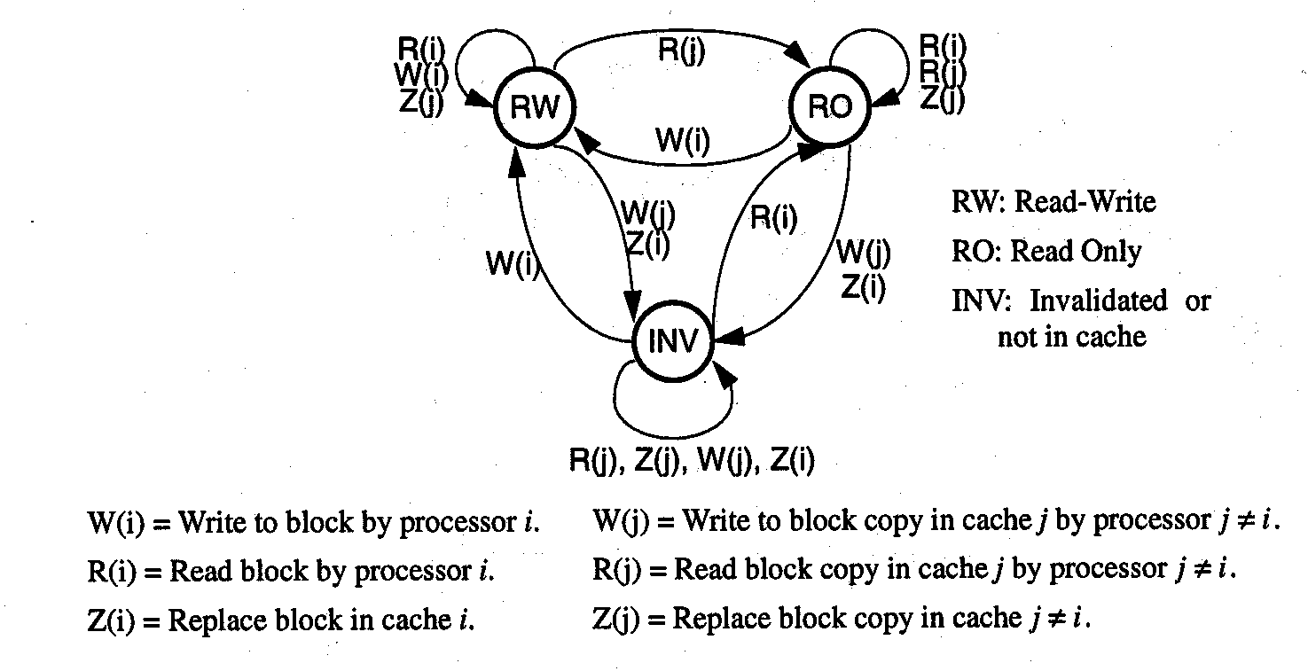

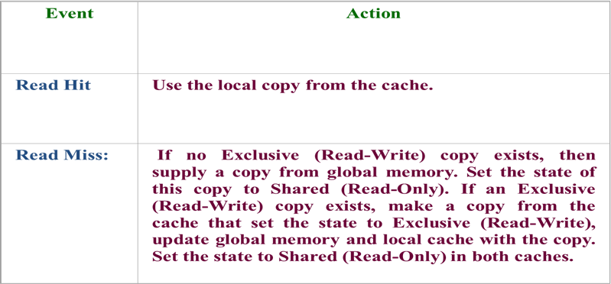
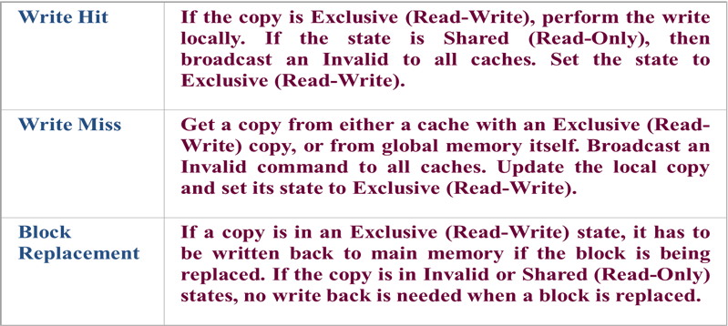
Figure 1 State machine and the table for write-back write invalidate cache coherence protocol

Q.
You are trying to decide what cache coherence protocol to use for a two processor SMP system. The two processors are connected together using a simple electrically shared bus that does not perform split-transactions. You have taken a trace of the reads and writes of a parallel program on the system, with the reads and writes listed in the order in which they occur. In particular, you are looking at four different cache lines: A, B, C, and D. Let’s at two different types of MSI protocol. In the first version, which we call MSI1, a read to a line that is in the modified state in the other processor makes the line go from modified to shared. In the second version, called MSI2, the line goes from modified to invalid state. Specify the state of the cache lines after each read and write. Also specify the bus transaction that occurs for each read and write (the bus transactions are BusRd, BusRdX, BusUpgr, and BusWB).

MSI protocol from the text book is presented below:

Directory based protocols

Questions related to the lecture
Give an example of coherence bandwidth requirements for snooping based systems

Why aren't snooping protocols scalable?

What are two main approaches in handling scalability:
- Replace non-‐scalable bandwidth substrate (bus) with scalable bandwidth network (point-‐to-‐point network, mesh)
- Replace non-‐scalable broadcast protocol (spam everyone) with scalable directory protocol (only communicate with processors that have desired cache copies)

Show how central directory protocol works.

Describe directory protocol for a read-miss when there is another modified copy and for a write miss when there are other shared copies.

What are the sizes of full mapped (baseline directory) and limited (limited-pointer) directories?

Be able to do the example where there is a small program with loads and stores and you will need to show the content of directories and caches during and after the execution of the program for different types of directory protocols. You will be given the state-transition diagram of the protocol.

Describe actions that every cache coherence protocol has to perform

What are home directory, requester node, dirty node and shared node?

Why the architecture with local memories scale better that the one with the shared memory?

What is NUMA, cc-NUMA and COMA architectures? Draw organizations of these different architectures.

Classify full mapped, limited and chained directory protocols as memory centric or cache centric.

If MSI protocol is executed in each cache in directory protocol, what will happen when there is cache line replacement and that line is not dirty?

If MSI protocol is executed in each cache in directory protocol, what will happen when there is cache line replacement and that line is dirty?

Why do we need a busy bit or a lock bit at the home node?

What is the number of network transactions in case of read miss for the baseline and for the Stanford Dash system? What has been done to reduce the number of transactions?

List advantages and disadvantages of chained directory protocols (cache centric directory protocols).

List properties of trhee types of intra-inter cluster coherence solutions.

What are the advantages of static and of dynamic page placement to cc-NUMA architectures? What are round-robin and first touch static placements?

When is it beneficial to perform page replication and when it is disadvantageous?

Short questions
Q. The full map (or baseline directory protocol) directory can cause significant memory overhead. For a fixed size of the main memory, the overhead of the directory will increase if we increase the size of cache blocks.
- True
- False
Q. Consider a multiprocessing system with 8 processors that have their local caches and they are connected to the main memory: If Full Map Directory cache coherence protocol is implemented, what is the number of bits per directory? Why?
Q. Explain the difference among the full-map, limited and chained directories in the directory protocols.
Q. In the multiprocessing system below, LM is the local memory and P is the processor. Is this UMA or NUMA system? Why?
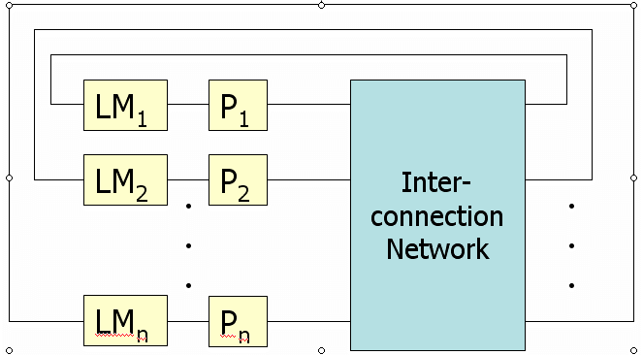

Q. What is the difference between full-mapped and limited directories?

Q. What are advantages and disadvantages of chained directory protocols in shared memory systems? How does chained memory protocol work?

Q. Propose a system and draw a block diagram of the shared memory system that will be able to perform the following
- Connect 8 processing elements with 8 memory blocks
- Provide non-blocking communication in case each processing element communicates with the different memory blocks

Q. The presence vectors shown below correspond to the full directory entries for some cache block using full-map directory protocol. Describe each step that happens in case of a write miss by cache 0.
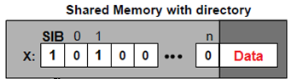

Q. What is the size of the centralized and limited directory in the system with 16 processors. Assume that 3 fields are used for the limited directory.

Problems

Q. Consider a cache-centric directory cache protocol according to the Figure below. We want to determine the time it takes to carry out an invalidation if N copies are maintained. Assume that a request and a response take K cycles. What would be the number of cycles under the same assumptions for a presence-flag-based cache protocol?
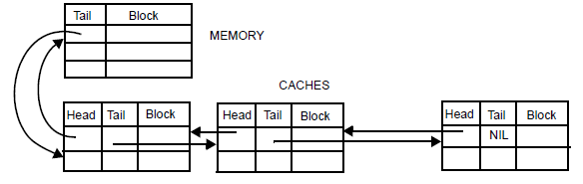

Q. The presence vectors shown below correspond to the full directory entries for some cache block using full-map directory protocol. Describe each step that happens in case of a write miss by cache 0.

Q.
Let us consider the following directory-based cache coherence protocols:
i) Status bits (a dirty bit and n valid/present bits) are maintained in the directory for each block comprising the main memory.
ii) Same as previous system as far as central directory is concerned, but the individual caches have an extra bit of status information associated with each block – the single bit which indicates that this cache is the only one in the system which contains a copy of the block.
iii) Replacing each of n valid/present bits with 2 status bit representing four possible states – not cached, clean in exactly one cache, clean in more than one cache, dirty in exactly one cache.
Compare the advantages and disadvantages of these schemes with respect to the amount of storage required in the directory, and the speed of lookup in case of write hit, write miss, read hit and read miss events.

Q. Consider a multiprocessing system with 8 processors that have their local caches and they are connected to the main memory.
- If Full Map Directory cache coherence protocol is implemented, what is the number of bits per directory? Why?

- If Limited Directory cache coherence protocol with only two pointers is implemented, what is the number of bits per directory? Why?

- Assume that Full Map Directory cache coherence protocol with Centralized Directory Invalidate is implemented. Assume that directory for address X contained all 0s at the beginning. Fill the following table for the following sequence of instructions:

Time instant | Operation | Content of the directory for X
1 | Processor 0 – read X
2 | Processor 5 – read X
3 | Processor 0 – writes to X

Centralized Directory Invalidate protocol description:
Invalidating signals and a pointer to the requesting processor are forwarded to all processors that have a copy of the block. Each invalidated cache sends an acknowledgment to the requesting processor. After the invalidation is complete, only the writing processor will have a cache with a copy of the block.

Interconnection networks

Questions related to the lecture

What is the width of the link?

What is the link bandwidth?

What is the advantage of asynchronous communication?

What is switch degree?

What is the maximum degree of the switches in 4x4 mesh network?

Distinguish between unicast, broadcast and multicast.

Describe the packet? Why is the routing information stored in the header?

Define and compare switching strategies.

What is routing, flow control and network topology?

What contributes to the end-to-end packet latency?

What are flit and phit?

Compute end-to-end delay for a given switching strategy.

Define network diameter and average routing distance.

What is the split-transaction bus? Why is it used? What changes in the system does one need to make in order to support split transaction buses?

What is the burst mode of the bus?

What is the difference between synchronies and Asynchronous buses? What is hand-shaking in buses?

Calculate the transaction time and latency when buses are used.

Understand the following topologies: crossbar switch, tree, multistage networks including omega and butterfly.

Compute network parameters/characteristics of all types of networks including both direct and indirect networks.

What are hypercubes and k-ary n-cubes?

How is routing performed in meshes, omega networks and hypercubes? Give examples of deterministic routing?

What is the difference between deterministic, oblivious and adaptive routing?

What are virtual channels? What are they used for?

How can deadlock be avoided for deterministic routing and how for adaptive?

Draw the architecture of the switch. Explain its components.

What is flow control and how is it implemented in the switch.

Short questions

Q. Explain why virtual buffers are not fully utilized when dateline approach is used for deadlock prevention.
Q. Select preferable routing choices for multiprocessor systems on a chip with 64 processors where reduction of power is one of main design goals
- Deterministic
- Oblivious
- Adaptive
Q. Which of the following flow control strategies use buffer to store a packet being denied the channel and keep it stored until the channel is free?
- Blocking flow control
- Virtual cut-through routing
- Detour after being blocked
Q. Is the number of physical channels the same as the number of virtual channels?
a. yes
b. no
Q. If reducing the amount of memories and buffers in a system-on-a-chip is a main design goal, which switching technique would you use:
- circuit switching
- virtual cut through
- wormhole
Q. What is the bisection width of a star network with 33 processors (1 in the middle and 32 leaf processors)?
Q. How many nodes are there is 4-ary tree (4-ary means that each intermediate node has 4 children) which height is 3 (3 levels of links and 4 levels of nodes)?
Q. Consider simple comparison between 16x16 Omega network and 16x16 crossbar network. While the crossbar uses cross points, the Omega network is using 2x2 switching elements (SE). Assume that the cost of the SE is four times that of a cross point. How many times is crossbar network more expensive than Omega network if we assume that the cost of the Omega network is determined only by its switching elements and the cost of the crossbar network is determined only by its cross points.
Q. Is it possible to use a crossbar switch for message passing networks. Please think about how you can connect different processors?
a. yes
b. no
Q. How many stages of 4x4 switches are needed for 16x16 multistage network?
Q. What bus allocation technique would end up in having empty slots if the master does not have data to send
- TDMA
- Round-robin
- Unequal priority scheme
Q. Why isn't daisy chain arbitration fair:
a) It can starve the masters that are further from the arbiter in the chain if the devices that are closer have a lot of data to transfer.
b) When one device starts its sequence of transactions it does not stop until it is finished.
Q. What bus allocation technique would work the best for systems where one master is more important than the others.
- TDMA
- Round-robin
- Unequal priority scheme
Q. What techniques/transactions can be used for the buses where fast and slow devices need to communicate? List at least 2.
Q. Is it possible to have concurrent transfers in hierarchical busses
- Yes
- No
- Only if the transfers do not go through bridges.

Q. What is the maximum degree of the switches in 4x4 mesh network?

Q. Diameter of 4x4 2D mesh, where each node is also connected to additional 3 nodes in the form of a linear array, is:

Q. What techniques/transactions in bus-based networks can be used where fast and slow devices need to communicate?
- Pipelined
- Split-transactions
- Burst-mode

Q. How many processor nodes Np and how many switches Ns are there is 4-ary tree (4-ary means that each intermediate node has 4 children) which height is 3 (3 levels of links and 4 levels of nodes)?
- Np=64
Ns=63

- Np=64
Ns=21

- Np=8
Ns=7

- Np=64
Ns=17

Q. The following network is asymmetric:
- Hypercube
- 2D Mesh
- Ring
Q. If the main concern in the design of the interconnection network is configurability (ability to easily add more nodes), then which multistage network should be used:
- Bus
- Omega network
- Crossbar network
Q. In a single-bus system that uses split transactions:
- Both masters and slaves have to compete for the bus by arbitration
- Only the masters have to compete for the bus by arbitration
- No arbitration is necessary

Q. In a four-dimensional hypercube, what nodes connect to node 12?
Q. Could adaptive routing affect memory consistency? How? If yes, how can this problem be addressed?
- Which of the following statements is false?
- Node duplication increases the overall number of operations in the system.
- Node duplication reduces communication delays.
- Node duplication creates coarse-grained nodes.

Q. Which of the following flow control strategies use buffer to store a packet being denied the channel?
- Blocking flow control
- Virtual cut-through routing
- Detour after being blocked

Q. Which of the following routing mechanisms is not deterministic?
- E-routing on a hypercube
- X-Y routing on a 2D mesh
- Routing on the crossbar network

Q. The main problem with a crossbar switch is:
  - We cannot connect all the processors to all the destinations all the time.
  - The propagation delay in the network.
  - It is expensive when we have lots of processors.

Q. In the PRAM model:
a) Processors have local private memory for inter-processor communication.
b) The CREW-PRAM subclass allows only one processor to read or write a memory location.
c) The conflicting “arbitrary” write policy chooses one value and ignores the others.

Q. What is a difference between the shared bus and the linear array?

Q. What is the difference between virtual cut through and wormhole routing?
Q. Compute the diameter and bisection width for 3D mesh with p=64 processors.

Q. Compute the diameter and bisection width for 2D torus with p=64 processors (assume that routing is bidirectional).

Q.
- What is the uniform random routing algorithm?
- Is this algorithm deterministic? Why?

Q.
- What is the difference between virtual cut through and blocking flow control?
- Which flow control strategy is used for wormhole routing?

Q. How many nodes are there is 4-ary tree (4-ary means that each intermediate node has 4 children) which height is 3 (3 levels of links and 4 levels of nodes):
- 85
- 21
- 15

Q. Which of the following flow control strategies use buffer to store a packet being denied the channel?
- Blocking flow control
- Virtual cut-through routing
- Detour after being blocked

Q. Which of the following routing mechanisms is not deterministic?
- E-routing on a hypercube
- X-Y routing on a 2D mesh
- Routing on the crossbar network

Q. In a single-bus system that uses split transactions
- Both masters and slaves have to compete for the bus by arbitration
- Only the masters have to compete for the bus by arbitration
- No arbitration is necessary

Q. What type of routing is weighted random routing?
Q. What is the advantage of the wormhole routing?
Q. Order the following networks based on their tolerance from faults (in decreasing order)
___ multi-bus (n buses)
___ crossbar
___ n-cube
___ k-ary n-cube

Q. Describe routing procedure in Omega networks? What type of routing is used?

Q. What are split transactions in buses?

Q. What is the diameter of
- A hypercube with 256 processors?
- A 2D mesh with 64 processors?
- A linear array with 32 processors?
- A star network with 17 processors (1 in the middle and 16 leaf processors)?
- A 2D torus with p processors (assume that routing is bidirectional) _________

Q. What is the bisection width of
- A hypercube with 256 processors?
- A 2d mesh with 64 processors?
- A linear array with 32 processors?
- A star network with 17 processors (1 in the middle and 16 leaf processors)?

Q. What is the difference between adaptive and oblivious routing?

Q.
Explain the following terms:
- Virtual channels versus physical channels.

A virtual channel is a logical link between two nodes. It is formed with a flit buffer in the source node, a physical channel between them, and a flit buffer in the receiver node. There are more than one virtual channels between two nodes. However, fewer number of physical channels are time-shared by all the virtual channels.

- Buffering flow control using virtual cut-through routing.

When two packets reach the same node and they request the same outgoing channel, the cut-through routing scheme uses a packet buffer to temporarily store one of the received packets. When the channel becomes available later, the stored packet will be transmitted then.

- How does one node in the message passing network know that the next node has the flit buffer full?

By using techniques called backpressure - inform the nodes to stop transmitting because all the flit buffers are full.

- If we compare a program that deals with arrays written for the vector and for the scalar processor, we can see that the vector program has the smaller number of instructions and it also executes the smaller number of operations. Why?

Smaller number of instructions: One vector operation replaces the whole loop.
Smaller number of operations: There is no loop overhead any more (increment of indexes and check if the loop is finished)

- What does “stride” mean in vector processor terminology?

- What is node duplication and when is it used?

Q. What is the virtual channel and what is it used for? Does the number of physical channels correspond to the number of virtual channels?

Q. What are burst transactions in buses? Why are they used?

Q. Describe the advantages of split transactions in buses?

Q. What is the diameter of a ring network with N nodes in case
- it supports two-way communication
- it supports only one-way communication

Q.

- Q. What is the diameter of a 2D torus with p processors (assume that routing is bidirectional)?

- What is the bisection width of a star network with 33 processors (1 in the middle and 32 leaf processors)?

- How many nodes are there is 4-ary tree (4-ary means that each intermediate node has 4 children) which height is 3 (3 levels of links and 4 levels of nodes)?

- Let’s consider a single-bus system that uses split transactions. Do both masters and slaves have to compete for the bus by arbitration? Why?

- Explain different types of arbitration for buses.

- Let’s consider sending a message between two network nodes. List all the sources of latency through the communication link.

Q. What is disadvantage of daisy chain arbitration?

Q. In bus-based systems memory is usually implemented as a slave device? Which technique used to improve bus performance will require that memory is also implemented as a master? Why?

Q. Explain different types of arbitration for buses.

Q. Select preferable choices for multiprocessor systems on a chip with 64 processors and explain why:
- Deterministic, oblivious or adaptive routing.
- Wormhole, or store and forward routing.
- Bus-based or mesh type of interconnection network.
- Snooping or directory based cache coherence.

Q. Would you select circuit switching or packet switching network for the streaming data application?

Q. What are the requirements for the bus system that implements burst transcactions? How can slave devices get access to the bus.

Q. Draw the block diagram of a router used in a manycore system based on a mesh network and explain functionality of all components of the router. Assume 2 virtual channels per input buffer. How many input buffers are needed?

Q. Assume that there are five pipeline stages in the router. Explain each stage.

Q. Let us consider 3x3 mesh network. How many cycles will take for propagation of a packet containing a head flit, and 4 body flits from the node in the bottom left to the upper right node? Assume again that each router has 5 pipeline stages.

Q. Let’s assume that the cache hierarchy in a network is implemented using private L1 and L2 caches in each core. Show steps needed to be taken in case of L1 and L2 write miss.

Q. What is the maximum number of peripherals that can be connected to the USB bus?
Q. Circle serial buses: RS232, USB, PCI, ISA.

Q. What are the problems with daisy chain arbitration?

Q. Will split-transaction buses introduce additional problems related to arbitrations? What problems?

Q. What is the difference between static and dynamic interconnection networks?

Q. What is the bisection width of a star network with 33 processors (1 in the middle and 32 leaf processors)?

Q. How many nodes are there is 3-ary fat tree (3-ary means that each intermediate node has 3 children) which height is 3 (3 levels of links and 4 levels of nodes)?

Q. What is the diameter of 5x7 torus network? What is the bisection width? What is the diameter of mxn torus network?

Q. What is the difference in the routing delay between store and forward and wormhole routing?

Q. Describe advantages and disadvantages of the following flow control mechanisms: buffering in virtual cut-through, blocking flow control, discard and retransmission, and detour after blocking.

Q. What is credit based flow control? How is it different from on-off control?

Q. What is the diameter, degree and bisection width of 4x6 torus network with bidirectional traffic?

Q. Describe how crossbar slicing works. If we use 2 3x3 switches instead of 1 5x5 switch, how can this help in performing X-Y routing? Draw configuration of these 2 3x3 switches.

Q. Why is operating system usually involved if communication is done through the shared memory and not to be involved if the communication is done through the direct communication?

Q. How does hierarchical bus increase bandwidth?

Q. Why does not the deadlock happen in case of X-Y routing?

Q. What is the difference in the routing delay between store and forward and wormhole routing?

Q. Why does T&S synchronization generate significant bus traffic?

Problems
Q. Consider 4x4 mesh network. Switching strategy is store-and-forward. The network clock frequency is 1 GHz and the phit size is 8 bits. The routing address occupies 2 phits (header of the packet), a payload of a packet is 128 bits. Assume that the sender and receiver overheads are zero and that wire delay is also zero. End-to-end network latency for sending a packet from the lower left to the upper right corner in nanoseconds is [1]. The minimum size buffer in each switch in bytes is [2].
Q. The trade-off in on-chip network design is the amount of buffer space compared to wire bandwidth. In traditional off-chip networks, the wire bandwidth is at a premium, but on-chip buffering is relatively inexpensive. With on-chip networks, the wiring bandwidth is high, but the buffer space takes up silicon area, the critical resource. Another aspect of on-chip networks that affects buffering is that they are more reliable than interchip networks. How are these facts used to decide about the type of switching and router design?
Q.
- Propose a system and draw a block diagram of the shared memory system that will be able to perform the following
  - Connect 8 processing elements with 8 memory blocks
  - Provide non-blocking communication in case each processing element communicates with a different memory block
- Which of the following types of system cannot be implemented using two processors and one memory unit: SISD, SIMD, MIMD, MISD

Q. Consider simple comparison between 16x16 Omega network and 16x16 crossbar network. While the crossbar uses cross points, the Omega network is using 2x2 switching elements (SE). Assume that the cost of the SE is four times that of a cross point. How many times is crossbar network more expensive than Omega network if we assume that the cost of the Omega network is determined only by its switching elements and the cost of the crossbar network is determined only by its cross points.

Q. Construct an 8-input Omega network using 2 x 2 switch modules in multiple stages. Show the routing of the message from input 010 to output 110.

Q. Consider the following 16x16 Omega network
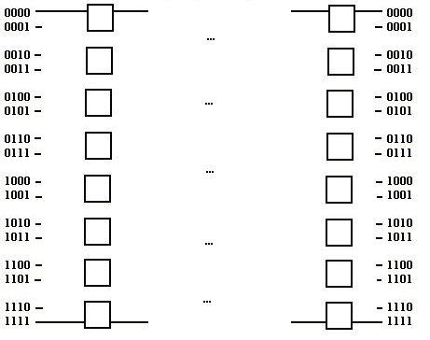
- Number of stages.
- Number of 2 x 2 switches needed to implement the network.
- Show switch settings for routing a message from node 1101 to node 0101 and from node 0111 to node 1001 simultaneously.
- Does blocking exist in this case?

Q. Consider the following network. What is the diameter, node degree and bisection width? Each block is a node in the network.

Q.

- Consider a multiprocessor system with 3 processors P1, P2 and P3. Assume that they are connected either using a shared bus, linear array or a ring. At time instant 1, all three processors would like to send a message so that P1 should send to P2, P2 to P3, and P3 to P1. Assume that processors have input and output buffers so that they can receive and send data at the same time. In addition, assume every link of every interconnect is the same speed. How long does this communication take and why?
- Bus

- Ring

- Linear array

- Answer the following questions:
- What is the diameter of a star network with 16 processors?

- What is the bisection width of a linear array with 32 processors?

- What is the number of 2x2 switches in a 16x16 baseline multistage network?

Q.
a) Draw a 16-input Omega network using 2 x 2 switches as building blocks.

b) Show the switch settings for routing a message from node 1011 to node 0101 and from node 0111 to node 1001 simultaneously. Does blocking exist in this case?

c) Consider simple comparison between 16x16 Omega network and 16x16 crossbar network. While the crossbar uses cross points, the Omega network is using 2x2 switching elements (SE). Assume that the cost of the SE is four times that of a cross point. Which network is more expensive and how many times if we assume that the cost of the Omega network is determined only by its switching elements and the cost of the crossbar network is determined only by its cross points.

Q. Using X-Y routing, show how the message is routed between the following source destination pairs:
- (1,1) and (3,2)
- (2,3) and (3,1)

Q. Consider a network with 8Gbits/sec bandwidth per channel. The delay of a single router is 8ns. The packet length is 256 bytes and the message travels between the source and the destination through 4 routers. What is the latency of this message if we use wormhole routing?

Q. a. Consider simple comparison between 16x16 Omega network and 16x16 crossbar networks. While the crossbar uses cross points, the Omega network is using 2x2 switching elements (SE). Assume that the cost of the SE is four times that of a cross point. Which network is more expensive and how many times if we assume that the cost of the Omega network is determined only by its switching elements and the cost of the crossbar network is determined only by its cross points.
b. Consider the following hybrid n-cube/b-tree network

011
100
110
010
111
101
001
000
000
111
100
101
011
010
001
to b-tree 100
to b-tree 001
to b-tree 111

The address of each node of the network follows the form xxxyyy where
xxx is the binary address of the n-cube
yyy is the binary address of the b-tree

For example node 110010 is highlighted in the network above
Calculate the degree (d) and the diameter (D) of this network (5 points).
Give the degree and the diameter of the network based on n, the number of address bits of the n-cube and the b-tree. For simplification, the number of address bits of the n-cube and the b-tree are always equal. For the network above, n would be 3. (5 points)
Q. A common communication pattern in scientific programs is to have nearest neighbor elements of a two-dimensional array to communicate in a given direction. This pattern is sometimes called NEWS communication, standing for north, east, west, and south—the directions on a compass. Map an 8 × 8 array of elements one-to-one onto 64 end node devices interconnected in the following topologies: bus, ring, 2D mesh, 2D torus, and fully connected. How long does it take in the best case for each node to send one message to its northern neighbor, one to its eastern neighbor and one to its western neighbour, assuming packets are allowed to use any minimal path provided by the topology? Ignore elements that have no northern or eastern or western neighbors. To simplify the analysis, assume all networks experience unit packet transport time for each network hop—transmission time for each hop sum to one. Also assume the delay through injection links is included in this unit time, and sending/receiving overhead is null.

Q. Consider the following networks. What is the diameter, node degree and bisection with for both networks:
a)

b) Each node below contains a small sub-network with 3 additional nodes as shown for node 3 below

Q.

- Explain the arbitration schemes in Figures 1 and 2.

- Explain decoding scheme applied in Figures 1 and 2? What decoding scheme is more popular nowadays in your opinion? What are their advantages and disadvantages?

- Why do not processor and DSP have the Decoder logic in Figure 2?

- Is it easier to add an additional component (slave or master) in bus architecture shown in Figure 1 or in Figure 2? Why?

- Consider bus architectures shown in Figures 1. Draw timing diagrams for a read cycle in which processor reads a word from Memory 1. Assume that the buses are synchronous, clocking is done on the rising edge and that the memory needs an additional clock cycle to perform reading. Be aware that arbitration and decoding also requires some time.

Figure 1

Figure 2

Q.

- Use multiplexers and other necessary logic to construct 3x3 crossbar switch network between 3 processors and 3 memory modules. Draw the crossbar network.
- Multiplexers are controlled by an arbiter. Arbiter accepts as an input the memory addresses and uses address decoder to decode the address and then generates the control signals. Draw the arbiter.

Q.

- Consider the 3x3 mesh following the with West-First Turn Model Algorithm like in Table 4.3 of [Jerger]- http://www.morganclaypool.com/doi/abs/10.2200/S00209ED1V01Y200907CAC008?journalCode=cac . Modify that table to support 4x4 mesh.
- Describe and draw cycle by cycle the propagation of a packet containing a head flit, and 4 body flits from the node (1,0) to (2,2).
- Now, let us zoom in and look only at the pipeline activity of one router. The router in each node looks like the one in Figure 6.1 from [Jerger]. Assume basic 5 stage pipeline of the router with no output buffers. Describe activities in each stage of the pipeline and show how different it is for header flit and for body flits. Assume the following implementation: single fixed-length queue buffer, with crossbar designed using crossbar slicing with round robin arbiter and separable allocator.

Q.

Let’s consider a 4x4 mesh network with source routing (implementation using source tables). Assume that there are two routes to be selected from each source to each destination.
- How does the intermediate node know where to forward the packet?
- Why would the size of the packet be different based on the distance between two nodes?
- What is the minimum and what is the maximum number of bits needed to encode routing information in the packet?
- Is it possible to implement adaptive routing using source tables?

Q.
- Let’s consider a 4x4 mesh network. Assume 2 virtual channels per input buffer for each router. How many input buffers are needed in the router? What is the size of the crossbar in the router? How many crosspoints does the crossbar have?
- Assume that there are five pipeline stages in the router. Explain each stage.
- How many cycles will take for propagation of a packet containing a head flit, and 4 body flits in this mesh network from the node in the bottom left to the upper right node? Assume again that each router has 5 pipeline stages, that the wormhole routing is used, that there are no congestions in the network and that minimal routing is used.

Q.
A common communication pattern in scientific programs is to have nearest neighbor elements of a two-dimensional array to communicate in a given direction. This pattern is sometimes called NEWS communication, standing for north, east, west, and south—the directions on a compass. Map an 8 × 8 array of elements one-to-one onto 64 end node devices interconnected in the following topologies: bus, ring, 2D mesh, fully connected, and fat tree. How long does it take in the best case for each node to send one message to its northern neighbor and one to its eastern neighbor, assuming packets are allowed to use any minimal path provided by the topology? What is the corresponding channel load? Ignore elements that have no northern or eastern neighbors. To simplify the analysis, assume all networks experience unit packet transport time for each network hop—that is, total transmission time for each hop sum to one. Also assume sending/receiving overhead is null.
Problems 1-8 are from [Huang93]
1. You are asked to design a direct network for a multicomputer with 64 nodes using a three-dimensional torus, a six-dimensional binary hypercube, and cubeconnected-cycles (CCC) with a minimum diameter. The following questions are related to the relative merits of these network topologies:
Let d be the node degree, D the network diameter, and I the total number of links on a network. Suppose the quality of a network is measured by (d x D x i)⁻¹. Rank the three architectures according to this quality measure.

2. Answer the following questions related to multistage networks:
a) How many legitimate states are there in a 4 x 4 switch module, including both 'broadcast and permutations? Justify your answer with reasoning.
b) Construct a 64-input Omega network using 4 x 4 switch modules in multiple stages. How many permutations can be implemented directly in a single pass through the e~k without blocking?

3. Topologically equivalent networks are those whose graph representations are isomorphic with the same interconnection capabilities. Prove the topological equivalence among the Omega, Flip, and Baseline networks.
(a) Prove that the Omega network is topologically equivalent to the Baseline network
(b) The Flip network (figure on the next page) is constructed using inverse perfect shuffle
for interstage connections. Prove that the Flip network is topologically equivalent to the Baseline network.
(c) Based on the results obtained in (a) and (b), prove the topological equivalence between the Flip network and the Omega network.
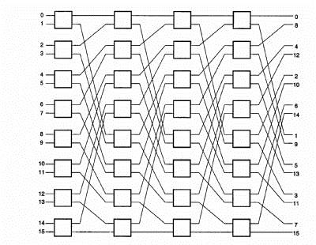

Flip network

4. Using AND and OR gates (no wired-OR) to construct an n x n crossbar switch network between n processors and n memory modules. Let the width f each crosspoint be w bits (or a word) in each direction.
(a) Prepare a schematic design of a typical crosspoint switch using Cij as the enable signal for the switch in the ith row and jth column. Estimate the total number of AND and OR gates needed as a function of n and w.
(b) Assume that processor Pi has higher priority over processor Pj if i < j when they are competing for access to the same memory module. Let k = log₂ n be the address width. Design an arbiter which generates all the crosspoint enable signals Cij again using only two-input AND and OR gates and some inverters if needed. The memory address decoder is assumed available from each processor and thus is not included in the arbiter design. Indicate the complexity of the arbiter design as a function of n and k.

5. For programs with each of the following sets of characteristics, would a shared memory multiprocessor or a message-passing multiprocessor be a better choice, all other factors being the same?
- Values tend to be computed well before they are used.
- The control structure is very complicated, making it difficult to predict which data will be needed by each processor.

6. Explain the following terms associated with multicomputer networks and message-passing mechanisms:
(a) Message, packets, and flits.
(b) Store-and-forward routing at packet level.
(c) Wormhole routing at flit level.
(d) Virtual channels versus physical channels.
(e) Buffer deadlock versus channel deadlock.
(f) Buffering flow control using virtual cut-through routing.
(g) Blocking flow control in wormhole routing.
(h) Discard and retransmission flow control.
(i) Detour flow control after being blocked.

7. Explain the following terms as applied to communication patterns in a message-passing network:
(a) Unicast versus multicast
(b) Broadcast versus conference
(c) Channel traffic or network traffic
(d) Network communication latency

8. Consider a 64-node hypercube network. Based on the E-cube routing algorithm, show how to route message from node (101101) to node (011010). All intermediate nodes must be identified on the routing path.

Multithreading

Questions related to the lecture

Will context switching take longer for the OoO superscalar processor then in-order in case of blocked multithreading implementation.

Is it common to have vacant slots in simultaneous multithreading?
Does SMT require large area to be implemented?

What needs to be replicated for SMT?

Short questions
Q. Will context switching take longer for the OoO superscalar processor then in-order in case of blocked multithreading implementation. Why?
Q. What is the common switching delay in RISC-based blocked multithreading processors?
- Processor switches threads every cycle.
- The delay corresponds to pipeline depth.
- The delay corresponds to L1 cache access latency.
Q. SMT increases the processor area approximately by
- 100%
- 50%
- 5%

Q. Select resources that need to be replicated to support blocking multithreading implementation.
- Cache
- ALU
- Register file
- Program counter

Q. Is the number of L1 cache misses larger or smaller in a multithread processor in comparison with RISC processor? Assume that both processors have L1 caches that are of same size and type.

Problems

Hypervisors

Questions related to the lecture

Why is hypervisor type 2 less efficient than type 1?

Why would we like to have more Operating systems in one system?

What is the function of the hypervisor?

Short questions
Q. What are events in Xen?
- Virtual communication channels
- Virtual interrupts
- Calls to virtual grant tables

Q. Is it possible to run multiple operating systems on different cores in a multicore embedded chip?
a. yes
b. no

Q. Is it possible to run multiple operating systems on different cores in a multicore chip? How is the access to hardware resources handled?

Q. Describe a set of steps that need to be performed in case of a page fault in a virtualization implementation with shadow page tables.

Problems

Processor architectures, accelerators and scheduling

Short questions
Q. How anti-dependencies and output dependencies affect execution of the code on superscalar processors? What technique is used to remove output and anti-dependencies? How are these dependencies removed?

Q. List and briefly describe three types of superscalar instruction issue policies?

Q. If we compare a program that deals with arrays written for the vector and for the scalar processor, we can see that the vector program has the smaller number of instructions and it also executes the smaller number of operations. Why?

Q. What does “stride” mean in vector processor terminology?

Q. If we compare a program that deals with arrays written for the vector and for the scalar processor, we can see that the vector program has the smaller number of instructions and it also executes the smaller number of operations. Why?

Q. Which of the following characteristics does not match with the superscalar architectures?
a) The amount of instruction-level parallelism varies widely depending on the type of code being executed.
b) Superscalar processors are used mainly for embedded system market
c) Superscalar processors rely on dynamic instruction scheduling

Q. In vector processors, does one instruction perform many operations?
- Yes
- No

Q. Processing instructions in parallel requires three major tasks:
1. checking dependencies between instructions to determine which instructions can be grouped together for parallel execution;
2. assigning instructions to the functional units on the hardware;
3. determining when instructions are initiated placed together into a single word.
In VLIW architectures the following steps are done by the compiler
- 1
- 1,2
- 1,2,3

Q. Which of the following characteristics does not match with the superscalar architectures?
- The amount of instruction-level parallelism varies widely depending on the type of code being executed.
- Superscalar processors are used mainly for embedded system market
- Superscalar processors rely on dynamic instruction scheduling

Q. What is the purpose of register renaming in pipeline processors?
Q. What do VLIW processors use loop unrolling?
Q. What is the difference between soft, firm and hard processors?

Q. Why is the control unit of CISC processors more complex than the control unit of RISC processors?

Q. What is the theoretical CPI of superscalar processor that can issue, execute and write 3 instructions in parallel?

Q. Draw schematically the architecture of a hardware performance counter. Describe each component.

Q. If the processor has only 2 performance counters, how it is possible to monitor more than 2 events? How is that implemented in practice? After the information from the performance counter is obtained (for example the number of TLB misses in a multiprocessor shared memory system) what can be done/improved?

Q. We see in the lecture on GPU architectures that SIMD processor in is actually a symmetric VLIW4 in AMD's GPU. Nvidia has an opposite approach and requires dynamic resolution of the dependencies. What GPU architecture would be in this case more power and area efficient?
- AMD
- NVIDIA
Q. Which of the following architectures does not rely on data paralelism
- Stream processors
- Risk Processors
- Multimedia SIMD
- GPUs
Q. Each kernel instance is a __________ or thread
- work item
- work group
- wave front

Q. What are the main benefits of OpenCL vs. CUDA? Select all that apply.
- OpenCL is made for heterogeneous computing platforms.
- OpenCL is hardware independent.
- OpenCL is usually executing faster than CUDA

Q. How does the GPU hide memory latency?
Q. List major architectural characteristics of DSP processors?

Q. What are the assumptions behind in-forest/out-of-forest scheduling algorithm?

Q. The register file of a RISC processor has size of 32x32 which means that there are 32 registers that can store 32 bits. If this register file is implemented using logic elements in the FPGA, how many logic elements will it take?

Q. What is the logic element in the FPGA?

Q. What are the sources of overhead in multiprocessing systems? Please explain at least 2 of them.
Q. What is the reason of using tightly coupled memory for NIOS II processors?

Q. What is the MAC unit in processor architectures? How is it implemented?

Q. What are networks-on-chip? Explain the main differences between networks on chip and systems on chip?

Q. What does “run to competition” mean in multicore terminology?

Q. Define grid and cloud computing and describe their differences.

Q. Describe the differences between Software as a Service, Platform as a Service and Infrastructure as a Service.

Q. What are the reasons for implementing the control unit of the multi-cycle processor using two ROM memories?

Q. What are the architectural components of DSP processor that make it different from regular RISC processors?

Q. If the vector processor has a register file that can fit 64 element arrays, is it possible to work with smaller or larger arrays? How?

Q. Node duplication is one of scheduling heuristics. Explain when the node duplication is used.
Q. In parallel systems communication overhead is significantly reducing speed-up. List some techniques for reducing communication overhead.

Problems
Q. Superscalar architectures
How long would the following instructions take to execute on an in-order superscalar processor with two execution units, where each execution unit can execute any operation. Load operation have a latency of 3 cycles, and all other operations have latency of 2 cycles. Assume that processor has a 6 stage pipeline.
LD r4, (r5)
LD r7, (r8)
ADD r9, r4, r7
LD r10, (r11)
Mul r12, r13, r14
SUB r2, r3, r1
ST (r2), r15
MUL r21, r4, r7
ST (r22), r23
ST (r24), r21

Q.
- Explain concept of Vector chaining.
- What are the components of a vector processor?
- Draw a block diagram (architecture) of a vector processor that has 3 functional units that supports forwarding. For each components provide reasonable values of parameters (the size, pipeline depth, ...) and explain why you selected those. For example, for the register file provide details about the number of registers, the width of the register, organization of the register file and so on.

Q. Scheduling
The following graph needs to be scheduled on 4 processors. Computation times are: 1 time unit for addition and 10 time units for multiplication. Communication delay for interprocessor communication is 16 time units, and it is 0 time units for communication of tasks executed inside the same processor. Perform clustering (grain packing) and group nodes intelligently so that the speedup in comparison with sequential execution is greater than 1. Show the Gant chart of the execution on 4 processors and compute the speedup.

Q. The processor presented in the Figure below is VLIW processor with 2 ALUs. The upper ALU is responsible for arithmetical, logical and branch operations, while the lower ALU is performing memory reference operations. The processor is fetching 2 32 bit instructions in one clock cycle. All instructions are executed in 5 clock cycles.
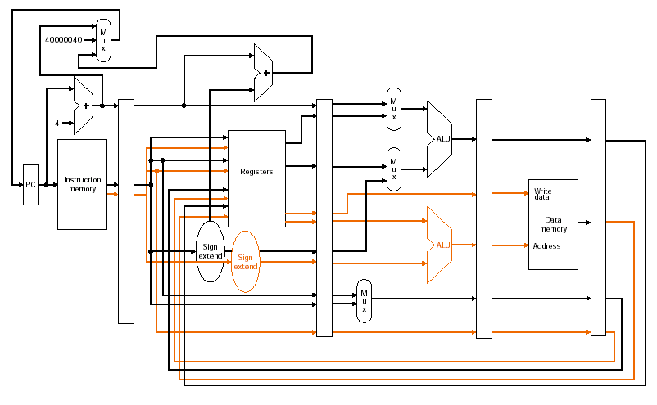
- Show pipelined activity for the following code (please take into account the fact that there are 2 parallel ALUs)

Loop: lw $t0, 0($s1)
addu $t0, $t0, $s2
sw $t0, 0($s1)
addi $s1, $s1, -4
bne $s1, $zero, Loop

- Perform loop unrolling once. Show again pipeline activity.

Q. Consider the in-forest graph in the task graph below. Assume that the communication delay is 0 and that the computation time is one unit. Schedule this in-forest graph on four processors. Follow the techniques explained in class.

Q. Perform scheduling of a graph shown below on 3 processors using scheduling inforest/outforest task graphs (list scheduling). Please note that communication delay is zero and that all the nodes require 1 time unit to finish their execution.

b. Consider the following code implemented on a vector processor used to multiply 64 element vector Y = a × X:

L.D F0,a ; load scalar a
LV V1,Rx ; load vector X
MULVS.D V2,V1,F0 ; vector-scalar multiply
SV Ry,V2 ; store the result
Instructions have the following startup delay: Load and store unit 12, Multiply unit 7 clock cycles.
Compute the total execution time of vector instructions if the instructions are chained. Assume that
- there is only 1 load/store unit
- there are one load and one store unit.

Q. Scheduling
A sequential program consists of the following seven statements, S1 through S8. Considering each statement as a separate process.

S1: A = B + C
S2: C = D + E
S3: F = G + E
S4: C = A + F
S5: M = G + C
S6: A = L + C
S7: A = E + A
S8: M = 2 * A

- Clearly identify input set I_{i} and output set O_{i} of each process.
- Use Bernstein’s conditions to detect the maximum parallelism embedded in this code. If any pair of process cannot be executed concurrently, specify which of the three conditions is not satisfied.
- Justify the portions that can be executed in parallel and the remaining portions that must be executed sequentially. Are Bernstein’s conditions sufficient for this problem?
- According to Bernstein’s conditions and taking into account the precedence relations, rewrite the code using parallel constructs such as Cobegin and Coend. No variable substitution is allowed. All statements can be executed in parallel if they are declared within the same block of a (Cobegin, Coend) pair.

Q.
a) Superscalar architectures
How long would the following instructions take to execute on an in-order superscalar processor with two execution units, where each execution unit can execute any operation. Load operation have a latency of 3 cycles, and all other operations have latency of 2 cycles. Assume that processor has a 6 stage pipeline.
LD r4, (r5)
LD r7, (r8)
ADD r9, r4, r7
LD r10, (r11)
Mul r12, r13, r14
SUB r2, r3, r1
ST (r2), r15
MUL r21, r4, r7
ST (r22), r23
ST (r24), r21

b) Vector architectures
Produce a vectorized version of the following program:
For i=1:N
B(i,1)=0
for j=1:M
A(i)=A(i)+B(i,j)*C(I,j)
End
D(i)=E(i)+A(i)
End

Assume that vectorized multiplication and addition operations are available.

Q. Consider a vector program given bellow for Y=X*Z+Y. All vectors have length of 64. Suppose that the hardware have 2 load/store units capable of performing 2 loads, or 2 stores, or 1 load and 1 store vector operation at the same time, one pipelined vector multiplier and one pipelined vector adder. Suppose that chaining is not allowed and that the start-up times are 12 for LV and SV, 7 for MULV and 6 for ADDV.
a. How many convoys do we have?
b. What is the total execution time?

LV V5,Rz ;load vector Z
LV V1,Rx ;load vector X
MULV V2,V1,V5 ;vector multiply
LV V3,Ry ;load vector Y
ADDV V4,V2,V3 ;vector add
SV Ry,V4 ;store the result

Q.
Vector processor architecture is given in the figure bellow. Vector register file is organized as 8 scalar register files. Each scalar register file has 64 64-bit registers and it has 1 write and 2 read ports.

- Why is the output of each functional unit connected to the input of all other functional units?

In order to allow for forwarding.

- How many convoys are needed to implement the following sequence of instructions (Y=aX+Y) on this architecture? Here, X and Y are 64 element arrays and Y is a constant. Assume that floating point multiplication is done on Functional Unit 1 and floating point addition on Functional Unit 2.

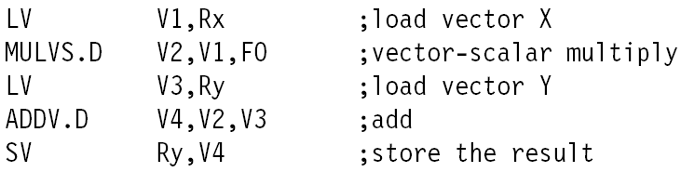

There is one convoy:
LD,LD can start at the same time
MULVS, ADDV and SV are chained and start after their startup time.

- The start-up times are 12 for LV and SV, 7 for MULVS and 6 for ADDV. What is the total execution time needed to execute Y=aX+Y from question b)?

12+7+6+12+64=101
Q.
- Show graphically true, anti and output dependencies for the following code fragment.
- How long will this code fragment take to execute on an in-order superscalar processor with two execution units? Any execution unit can execute any instruction and the latency of all instructions is one cycle? Assume that the pipeline depth is 5 stages.

I1: LD r1, (r2)
I2: SUB r4, r5,r6
I3: ADD r3, r1, r7
I4: MUL r8, r3, r3
I5: ST (r11), r4
I6: ST (r9), r8
I7: ADD r15, r14, r10
I8: MUL r10, r15, r10
I9: ST (r9), r10
Q. The following task graph is clustered and scheduled for execution on 2 processors. Here (A,4) means that node A needs 4 clock cycle to execute its function. The number next to the edge represents communication delay: for example (a,1) means that the communication delay of the edge from the node A is 1. Assume that communication delays between nodes in the same cluster are zero.

1. Draw the Gantt chart of the schedule on 2 processors. What is the total execution time? (6 points)
2. Propose at least one other clustering method that can reduce total execution time and draw the Gantt chart of the schedule on 2 processors. (6 points)

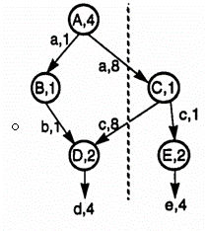

Q.
a. Consider a vector program given bellow for Y=X*Z+Y. All vectors have length of 64. Suppose that the hardware have 2 load/store units capable of performing 2 loads, or 2 stores, or 1 load and 1 store vector operation at the same time, one pipelined vector multiplier and one pipelined vector adder. Suppose that chaining is not allowed and that the start-up times are 12 for LV and SV, 7 for MULV and 6 for ADDV.
a. How many convoys do we have?
b. What is the total execution time?

LV V5,Rz ;load vector Z
LV V1,Rx ;load vector X
MULV V2,V1,V5 ;vector multiply
LV V3,Ry ;load vector Y
ADDV V4,V2,V3 ;vector add
SV Ry,V4 ;store the result

b. Figure on the next slide shows an example of a superscalar processor organization. The processor can issue two instructions per cycle if there is no resource conflict and no data dependence problem. There are essentially two pipelines, with four processing stages (fetch, decode, execute, and store). Each pipeline has its own fetch decode and store unit. Four functional units (multiplier, adder, logic unit, and load unit are available for use in the execute stage and are shared by the two pipelines on a dynamic basis. The two store units can be dynamically used by the two pipeline depending on availability at a particular cycle. There is a lookahead window with its own fetch and decoding logic. This window is used for instruction lookahead for out-of-order instruction issue. Forwarding of instructions in the execution stage is implemented but it is not shown in the picture.
- What dependencies exist in the program?
- Show the pipeline activity for this program on the processor using in-order issue with in-order completion policies and using a presentation similar to the Figure. Lookahead window is not used.
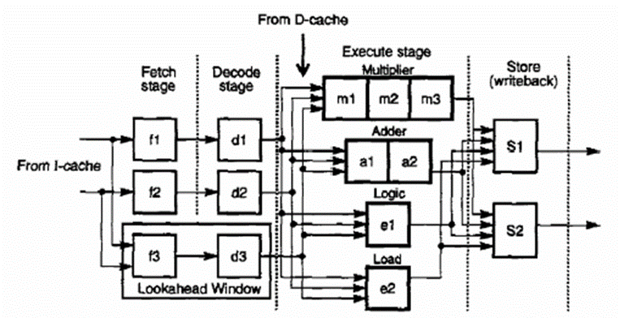
I1: MUL R12,R13,R14 ;R12 <- R13 * R14
I2: ADD R1,R8,R9 ;R1 <-R8 + R9
I3: OR R4,R2,R3 ;R4 <- R2 OR R3
I4: OR R5,R6,R7 ;R5 <-R6 OR R7
I5: ADD R4,R5,R11 ;R4 <- R5+ R11
I6: ADD R11,R2,R3 ;R11 <- R2 + R3

Q. The program bellow is executed on the 5 stage pipelined MIPS processor described in chapter 6. Answer the following questions about this program.

loop1: lw $6, 100($0)
ori $6, $6, 4
add $5, $7, $4
slt $7, $6, $3
beq $5, $4, loop2
sw $7, 200($0)
loop2: or $8, $5, $7
addi $5, $5, 6
lw $7, 100($8)
beq $8,$0, loop1

Assume the control unit does not have any hazard detection, forwarding and flushing and that the register file will not write and then read a new register value in one clock cycle. Rewrite the code by adding the minimum number of NOPs to eliminate potential data and branch hazards (5 points).

Total number of NOPs requires is ____________ (2 points)

Assume that the control unit is improved by adding the hazard and forwarding unit, adding a branch compare unit to the decode stage and the register file writes and reads a new value in a single clock cycle. Determine the number of clock cycles required to complete the first loop execution of the original code sequence.

This program need to be stalled and/or to flush the pipeline an additional _______ clock cycles, so the total of _________ clock cycles is required for execution (do not include time to initially fill the pipeline). (5 points)
The program achieves average CPI (clocks per instruction) of ________ . (do not include time to initially fill the pipeline). (3 points)

